

300 NW 13th Avenue
Portland, OR 97209 USA
503-227-0222 phone
503-227-0008 fax
gallery@bullseyeglass.com
www.bullseyegallery.com

November 19, 2009 FOR IMMEDIATE RELEASE

Bullseye at Art Miami 2009

When: December 2 - 6, 2009
Wednesday - Saturday, 11:00 am - 7:00 pm
Sunday, 11:00 am - 5:00 pm

Where: The Art Miami Pavilion
The Miami Midtown Arts District
Miami, FL 33127

More Info www.art-miami.com

Bullseye Gallery is pleased to participate in Art Miami, December 2 - 6, 2009 with works by five international artists working in kilnformed glass: Jun Kaneko (Japan/USA), Richard Whiteley (Australia), Mel Douglas (Australia), Jessica Loughlin (Australia), and April Surgent (USA).

Trained as a painter in his native Japan but best known for his monumental ceramic sculptures, Jun Kaneko has worked with Bullseye Glass for eight years in transitioning his visual language to the medium of glass. Major works from the Kaneko/Bullseye projects are now in museum collections from London (the V & A) to Australia (Queensland Art Gallery) with selected pieces to be available at Art Miami.

Bullseye’s 25-year history of collaboration with the Australian National University’s School of Art is represented by the sculptural and wall works of four of the program’s graduates.

Richard Whiteley currently heads the ANU program. Whiteley’s kilncast sculpture explores space, using glass as a substrate activated by light. The material qualities of glass - transparency and translucency - are the agents within the work that create the dialogue between voids and solids. Whiteley’s work is included in the Palm Springs Art Museum in California and the Powerhouse Museum in Sydney, Australia.

For Mel Douglas, the finished artwork reflects the act of creation; her subtle pieces are marked by countless, meditative, hand-engraved contour lines. Douglas has been featured in numerous international publications and her art is included in the permanent museum collections of the National Gallery of Australia in Canberra and the Corning Museum of Glass in New York.

Drawing inspiration from the landlocked salt lakes of her native Australia, Jessica Loughlin creates an illusory sense of depth in her quiet horizons of glass powders and cast layers. Loughlin’s work is included in the permanent collections of the Glasmuseet Ebeltoft in Denmark, the National Gallery of Australia, and the Victoria and Albert Museum, London.

Using cameo engraving to capture scenes in both urban and rural environments, April Surgent’s wall panels are figurative reflections of her surroundings. Her work is included in the collections of the Chrysler Museum of Art in Norfolk, Virginia and the Museum of Glass in Tacoma, Washington.

To view artwork online or download artist statements and CVs, please visit www.bullseyegallery.com. To request high-resolution images or to schedule an interview, please contact Ryan Watson: ryanwatson@bullseyeglass.com; 503-227-0222.

About Art Miami: Celebrating its 20th anniversary, Art Miami is the city’s longest running contemporary art fair. Located in the emerging Midtown Miami Arts District, the annual event showcases a wide variety of art from more than 80 leading national and international contemporary art galleries and prominent institutions.

About the gallery: Bullseye Gallery works with a select group of international artists with the aim of furthering exceptional design in glass through innovation in material and method. The gallery is part of Bullseye Glass Company, a maker of colored glass for art and architecture since 1974.

###
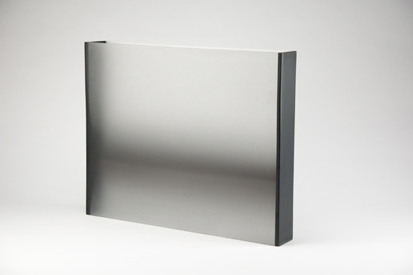
Jessica Loughlin, Inversion 2, 2009
cast, kilnformed and coldworked glass 15 x 18.5 x 3 inches
Photo: Michael Endo
Image courtesy of Bullseye Gallery

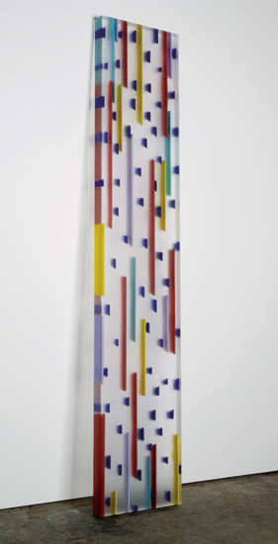

Jun Kaneko, Tropical Shower 2, 2007
kilnformed glass, 83.875 x 16.75 x 8.5 inches
Photo: Ryan Watson
Image courtesy of Bullseye Gallery

