

300 NW 13th Avenue
Portland, OR 97209 USA
503-227-0222 phone
503-227-0008 fax
gallery@bullseyeglass.com
www.bullseyegallery.com

June 26, 2009 FOR IMMEDIATE RELEASE

Bullseye at Art Santa Fe 2009

When: July 24 - 26, 2009
Friday - Sunday, 11:00 am – 6:00 pm

Opening Night: Thursday, July 23, 5:00 – 8:00 pm

Where: El Museo Cultural de Santa Fe
1615 Paseo De Peralta, #B
Santa Fe, NM 87501

More Info: www.artsantafe.com

Santa Fe, NM – Bullseye Gallery is pleased to return to New Mexico for Art Santa Fe, held at El Museo Cultural in the up-and-coming Railyard Arts District, July 24-26, 2009. For this intimate contemporary art fair, Bullseye will exhibit works by three internationally acclaimed Australian artists: Cobi Cockburn, Mel Douglas, and Jessica Loughlin. As a group, their pieces share a high degree of technical refinement and a quiet, striking beauty.

Cobi Cockburn blends rigorous technique with delicate, subdued forms that evoke the grasses and warm landscapes of the Australian environment. Her work has received Australia’s premier glass award, the Ranamok Glass Prize, as well as the Talente Prize (Munich), and is in the collections of California's Palm Springs Art Museum and New York's Corning Museum of Glass.

For Mel Douglas, the finished artwork reflects the act of creation; her subtle pieces are marked by countless, meditative, hand-engraved contour lines. Douglas has been featured in numerous international publications and her art is included in the permanent museum collections of the National Gallery of Australia in Canberra and the Corning Museum of Glass. Her work has earned Douglas many grants and awards, including the 2002 Ranamok Glass Prize.

Drawing inspiration from the landlocked salt lakes of the Australian outback, Jessica Loughlin creates an illusory sense of depth in her quiet horizons of glass powders and cast layers. Loughlin received the Tom Malone Prize from the Art Gallery of Western Australia in 2004 and 2007 and was the 2001 winner of the Outstanding New Artist in Glass award from UrbanGlass. Her work is included in the permanent collections of the National Gallery of Australia and the Victoria and Albert Museum in London, and is currently being acquired by the New Mexico Museum of Art.

To view artwork online or download artist statements and CVs, please visit www.bullseyegallery.com. To request additional information or high-resolution images, please contact Patrick Leonard: patrickleonard@bullseyeglass.com; 503-227-0222. To schedule an interview, please contact Jamie Truppi: jamietruppi@bullseyeglass.com; 503-227-0222.

About the gallery: Bullseye Gallery works with a select group of international artists with the aim of furthering exceptional design in glass through innovation in material and method. The gallery is part of Bullseye Glass Company, a maker of colored glass for art and architecture since 1974.
###

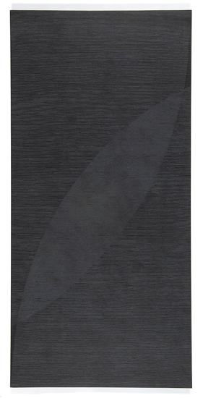

Mel Douglas, Open Field #2, 2007
fused, coldworked and engraved glass, 34.75 x 17.5 x .875 inches installed
Photo: S. Hay
Image courtesy of Bullseye Gallery

