

300 NW 13th Avenue
Portland, OR 97209 USA
503-227-0222 phone
503-227-0008 fax
gallery@bullseyeglass.com
www.bullseyegallery.com

April 8, 2009 FOR IMMEDIATE RELEASE

Emerging Perspectives: The RIT Project
Recent RIT students share the results of their factory artist exchange

When: Tuesday, May 5 – Tuesday, June 23, 2009
Tuesday – Saturday, 10:00 am – 5:00 pm
(and by appointment)

Where: Bullseye Gallery
300 NW 13th Avenue
Portland, OR 97209 USA
View map

Reception: Wednesday, May 6, 5:30 – 7:30 pm

First Thursday: May 7, open until 8:00 pm
June 4, open until 8:00 pm

Filling the Void: BECon Presenters
New cast glass sculpture by local and international artists participating in the BECon glass conference

When: Tuesday, May 19 – Saturday, July 25, 2009
Tuesday – Saturday, 10:00 am – 5:00 pm
(and by appointment)

Where: Bullseye Gallery
300 NW 13th Avenue
Portland, OR 97209 USA
View map

Reception: Wednesday, June 3, 5:30 – 7:30 pm

First Thursday: June 4, open until 8:00 pm
July 2, open until 8:00 pm

Portland, OR – Bullseye Gallery is excited to announce two special exhibits in conjunction with this year’s BECon conference on kilnformed glass. Emerging Perspectives and Filling the Void will feature artists at two very different points in their careers – recent graduates and established artmakers, respectively – whose work is unified by their shared techniques. Taken as a whole, the work will reflect some of the current practices in kilncast glass, while also envisioning the future development of kilnforming. Emerging Perspectives will be on view from May 5 – June 23, 2009 and Filling the Void will be in the gallery from May 19 – July 25, 2009.

Beginning in late 2008, three graduates and one current student of the glass program at the Rochester Institute of Technology spent a month at the Bullseye Research & Education Department doing exploratory work in the medium of kilncasting. Emerging Perspectives: The RIT Project will share the pieces that artists Rebecca Arday, Shane Caryl, Drew Smith, and Cassandra Straubing developed during this exchange. While it is clear from their work that these four young artists all share a fine degree of technical skill, their art also reveals a common interest in history – both personal and communal.

During the months surrounding BECon 2009, Bullseye Gallery will also exhibit new sculptural work by the international presenters, artists and educators involved in the conference. Filling the Void will feature a wide array of work by artists Howard Ben Tré (USA), Heike Brachlow (Germany/UK), Chick Butcher (Australia), Daniel Clayman (USA), Jacqueline Cooley (UK), Melanie Hunter (USA), Marshall Hyde (USA), Alicia Lomné (USA), Clifford Rainey (Ireland/USA), Nathan Sandberg (USA), Jeffrey Sarmiento (USA/UK), Ted Sawyer (USA), Richard Whiteley (Australia), Erik Whittemore (USA), and Ann Wolff (Germany/Sweden).

Portland’s biennial BECon is the glass industry's foremost conference on kilnforming. This year, the event will focus on kilncasting by inviting leading artists and technical experts to share their knowledge and vision through a series of panels and workshops. For 2009, the conference has moved out of the traditional hotel setting and onto the metropolitan campus of Portland State University, thanks to co-sponsorship by the university art department.

To view the artwork online or download the artists’ statements and CVs, please visit www.bullseyegallery.com. To receive additional information, request high-resolution images, or schedule an interview, please contact Patrick Leonard: patrickleonard@bullseyeglass.com; 503-227-0222.
# #
About the gallery: Bullseye Gallery works with a select group of international artists with the aim of furthering exceptional design in glass through innovation in material and method. The gallery is part of Bullseye Glass Company, a maker of colored glass for art and architecture since 1974.
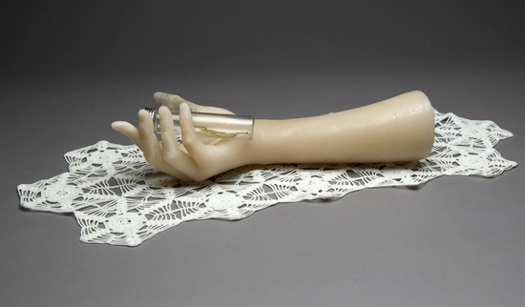
# # #

Rebecca Arday, Antidote, 2009, kilncast and flameworked glass, found object,
3.375 x 20.25 x 9 inches, Photo: P. Leonard, Image courtesy of Bullseye Gallery

