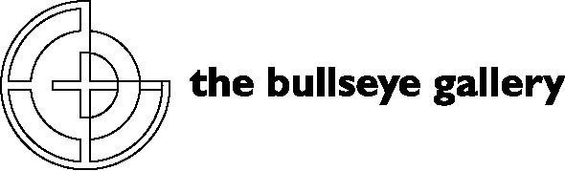

300 NW 13th Avenue
Portland, OR 97209 USA
503-227-0222 phone
503-227-0008 fax
nicoleleaper@bullseyeglass.com
bullseyeconnectiongallery.com

November 2, 2006 FOR IMMEDIATE RELEASE

Claudia Borella at Bullseye: “A Passage From New Zealand”

When: November 18 , 2006 – January 20, 2007
Tuesday – Saturday, 10:00 am – 5:00 pm
(and by appointment)

Where: The Bullseye Gallery
300 NW 13th Avenue
Portland, OR 97209 USA
view map

Artist Reception: Wednesday, December 6, 5:30 pm - 7:30 pm

First Thursday: December 7, 5:00 pm – 8:00 pm
January 4, 5:00 pm – 8:00 pm

Portland, OR – Bullseye is pleased to present Claudia Borella’s kilnformed glass panels during her solo exhibition, “A Passage From New Zealand,” at the Bullseye Gallery November 18 , 2006 – January 20, 2007.

Originally trained as an industrial designer at the University of Canberra in the late 1980’s, Borella later specialized in glass and received her BFA at the Australian National University’s Canberra School of Art. Borella has been working with Bullseye glass for over a decade. This exhibition represents the return to her full time glass practice last year after migrating to New Zealand and several years of practice as a glass educator. Claudia Borella now lives and creates work in Wanganui, New Zealand.

The works of this series were produced in the upper northern area of New Zealand, the Waitakere Ranges, a coastline surrounded by rainforest and infused with filtered, radiating and reflected light. Borella uses line, color and mathematics to inform the visual language and content of the overall works, but the new works exhibited in A Passage From New Zealand also evoke a sense of environment. Metaphysical explorations of lunar movement, time, and light are developed within the series. The works also make reference to the concept of bone and jade carving, a traditional practice adopted by the Maori to express their own religious and cultural meaning.

“Inspiration for my work is often related to architectural spaces and the living environment, focusing on personalizing objects typically found in these environments,” says Borella. “From a broad perspective, my work operates on a metaphorical level, exploring the universal boundaries of language and semantics – sign and symbolism that can transcend cultural barriers to create a common dialogue or language. From this perspective, the work remains unable to be stylistically classified as typically Australian, Italian, Japanese or Pacific, although with certainty the independent philosophies of these cultures continue to influence the personal development of my work.”

Borella’s work has been exhibited internationally and is included in the following collections:
Artbank, Australia
Australian National University, Institute of the Arts Collection, Canberra, Australia
Dowse Museum, Wellington, New Zealand
Glasmuseum, Ebeltoft, Denmark
Merrill Lynch Corporate Collection, Australia
National Gallery of Australia Collection, Canberra, Australia
RFC Glass Collection (Resource Finance Corporation), Sydney, Australia
Toyama Institute of Glass Art, Toyama, Japan
Wagga Wagga Regional Art Gallery, Wagga Wagga, Australia

To view exhibitions, find out more about the gallery and download artist statements and curricula vitae, please visit the gallery online at bullseyeconnectiongallery.com.

To receive additional information, request high-resolution images, or schedule an interview, please contact Nicole Leaper by phone at 503-227-0222 or by email at nicoleleaper@bullseyeglass.com.
#

