

300 NW 13th Avenue
Portland, OR 97209 USA
503-227-0222 phone
503-227-0008 fax
gallery@bullseyeglass.com
bullseyegallery.com

January 18, 2007 FOR IMMEDIATE RELEASE

Bullseye presents Building Art: The Casey Story

When: January 19 to February 24, 2007
Tuesday – Saturday, 10:00 am – 5:00 pm
(and by appointment)

Where: Bullseye Gallery
300 NW 13th Avenue
Portland, OR 97209 USA
View map

First Thursday: February 1, 5:00 pm – 8:00 pm

More information: The Casey www.thecasey.com
Gerding Edlen Development www.gerdingedlen.com
GBD Architects www.gbdarchitects.com
Bullseye Glass Company www.bullseyeglass.com
Bullseye Gallery www.bullseyegallery.com

Portland, OR - From January 19 to February 24, 2007, Bullseye Gallery will dedicate the front exhibition area of its Pearl District gallery to the story of a unique collaboration: Gerding Edlen Development, GBD Architects, Bullseye Glass Company and local artists working together to integrate glass and art into the architecture of GED's 16-story quarter-block condominium tower, The Casey, that is rising immediately to the east of the gallery – as the glass artwork "cooks" in Bullseye's factory kilns across the river. Building Art: The Casey Story marks the midway point in the creation of fifty artist-designed glass panels destined for the interior and exterior of the The Casey.

Building Art will be the first public viewing of Martha Pfanschmidt’s large-scale glass panels, currently in fabrication at the Bullseye factory. Ranging from 8 to 16 feet tall, the vibrant, multi-layered panels of colored glass will grace the main and elevator lobbies of each of the 16 floors of The Casey. Historically a printmaker, Pfanschmidt began working with glass during an artist exchange with Bullseye in 2004.

The exhibition will also spotlight 5 of the 15 kiln-glass panels that will eventually rise 15 floors on the exterior of the building. A collaboration between GBD designer Dustin White and Bullseye’s Ted Sawyer and Dan Schwoerer, the panels were fabricated by Fireart Glass.

Finally, an intimately scaled glass portrait of building namesake Casey Jones, planned for installation at street level on The Casey’s exterior, designed and executed by artist Catharine Newell, will also be on view.

To view exhibitions, find out more about the Bullseye Gallery and download artist statements and curricula vitae, please visit the gallery online at bullseyegallery.com.

To receive additional information, request high-resolution images, or schedule an interview, please contact Nicole Leaper by phone at 503-227-0222 or by email at nicoleleaper@bullseyeglass.com.

#

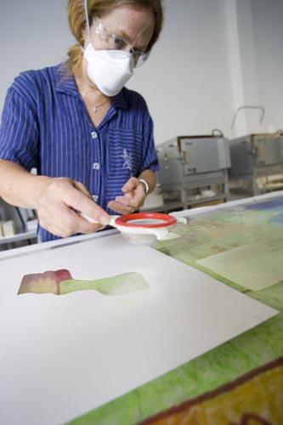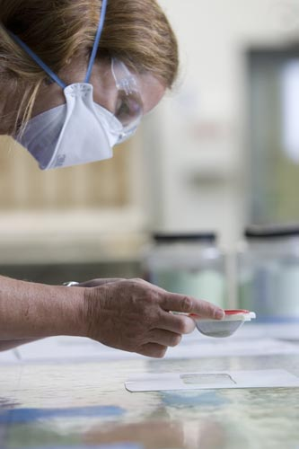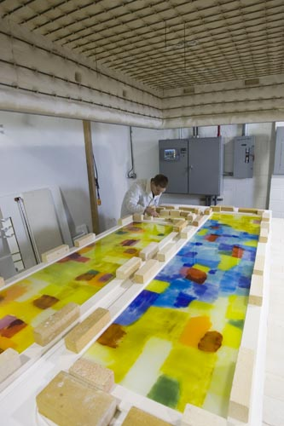

Martha Pfanschmidt prepares kilnformed glass panels for The Casey
at the Bullseye Glass factory studios, September 2006. Photos: J. Hart.

