

Nicole Leaper
Bullseye Connection Gallery
300 NW 13th Avenue
Portland, OR 97209 USA
503-227-0222 phone
503-227-0008 fax
bullseyeconnectiongallery.com
nicoleleaper@bullseyeglass.com

December 29, 2005 FOR IMMEDIATE RELEASE

Ceramists work in glass: ClayFusion

When: March 1 - 31, 2006
Tuesday – Saturday, 10:00 am – 5:00 pm
(and by appointment)

Where: Bullseye Connection Gallery
300 NW 13th Avenue
Portland, OR 97209 USA
view map

First Thursday: March 2, 5:00 – 8:00 pm

Concurrent with the 40th Annual NCECA Conference (National Council on Education for the Ceramic Arts) Bullseye is pleased to present ClayFusion, a collection of work by ceramic artists working in glass. Artists include Judy Hill, Deborah Horrell, Jun Kaneko, Tom Kearcher, Jim Koudelka, Thomas Orr, Ted Sawyer, Deborah Siegal, and Ted Vogel. These contemporary ceramists apply their diverse themes to a parallel kilnformed medium: glass. The result is an intriguing narrative about the unique dynamic between ceramics and glass.

ClayFusion features a small special exhibition of glass Sushi Plates by master ceramist Jun Kaneko. Spare geometries of clear and primary-colored glass, the small functional works are rare treasures by an artist who typically works on a monumental - and decidedly non-functional - scale. Kaneko’s work is included in public collections and museums worldwide, including the Bullseye Glass Decorative Arts Gallery of the new Center for Modern and Contemporary Art at the Portland Art Museum.

To view exhibitions, find out more about the Bullseye Connection Gallery and download artist statements and curricula vitae, please visit the gallery online at bullseyeconnectiongallery.com.

To receive additional information, request high-resolution images, or schedule an interview, please contact Nicole Leaper by phone at 503-227-0222 or by email at nicoleleaper@bullseyeglass.com.

###

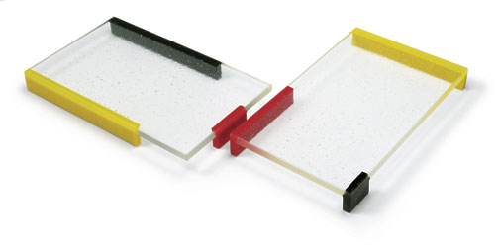

from left to right:
Jun Kaneko, Sushi Plate K, 2005, kilnformed glass, 1 x 10 x 6 inches
Jun Kaneko, Sushi Plate C, 2005, kilnformed glass, 1 x 10 x 6 inches
Photographer: R. Watson

