

300 NW 13th Avenue
Portland, OR 97209 USA
503-227-0222 phone
503-227-0008 fax
gallery@bullseyeglass.com
www.bullseyegallery.com

September 21, 2010 FOR IMMEDIATE RELEASE

Mel Douglas: Eventide
Mel Douglas presents meticulous, intimate works inspired by a recent residency in northern Scotland.

When: Wednesday, October 6 – Saturday, November 20, 2010
Tuesday – Saturday, 10:00 am – 5:00 pm
(and by appointment)

Where: Bullseye Gallery
300 NW 13th Avenue
Portland, OR 97209 USA
View map

First Thursday: October 7, open until 8:00 pm
November 4, open until 8:00 pm

Portland, OR – Bullseye Gallery presents a solo exhibition by Australian artist Mel Douglas. Eventide will be on view October 6 through November 20, 2010.

“I find beauty and poetry in the ordinary things that represent or allude to changes in the terrain,” explains Australian artist Mel Douglas. Her new series is a meditation on the landscape that surrounded her during a recent residency in northern Scotland. “The changes that occur," Douglas continues, "within the landscape…have inspired me: the quiet shadows that appear with the last light of day and the shimmer of fading light across a body of water.” Eventide, a series of kilnformed and engraved works, recalls at once the windswept landscape, the waning light of the day, and the feel of warm river rocks underfoot.

Following study at Australian National University School of Art in Canberra, Douglas has exhibited work at galleries in Australia, the United States, Italy and Singapore. Her work has been featured in numerous international publications and is included in the permanent collections of the National Gallery of Australia in Canberra and the Corning Museum of Glass in New York. Her delicate, subtle work has earned Douglas many grants and awards, including the 2002 Ranamok Glass Prize.

To view artwork online or download artist statements and CVs, please visit www.bullseyegallery.com. To request high-resolution images or to schedule an interview, please contact Michael Endo: michaelendo@bullseyeglass.com; 503-227-0222.
# #
About the gallery: Bullseye Gallery offers contemporary art objects and experiences examining the potential and complexity of kilnformed glass. The gallery is part of Bullseye Glass Company, a maker of glass for art and architecture since 1974.
# # #

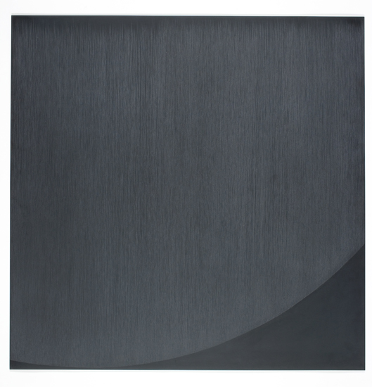

Mel Douglas, Open Field #6, 2010
fused, coldworked and engraved glass
31.5 x 31.5 x .25 inches
Photo: S. Hay, Image courtesy of Bullseye Gallery

