300 NW 13th Avenue
Portland, OR 97209 USA
503-227-0222 phone
503-227-0008 fax
gallery@bullseyeglass.com
www.bullseyegallery.com
June 13, 2014 FOR IMMEDIATE RELEASE

Emily Nachison: The Realm of Quantifiable Truths
A solo exhibition exploring measurement, materiality and mythology

When: July 2 – August 30, 2014
Tuesday – Saturday, 10:00 am – 5:00 pm
(and by appointment)

Where: Bullseye Gallery
300 NW 13th Avenue
Portland, OR 97209 USA
View map

Artist Reception: Wednesday, July 2, 5:30 – 7:30 pm

Portland, OR – Bullseye Gallery presents The Realm of Quantifiable Truths, a debut solo exhibition by Portland-based artist Emily Nachison, on view July 2 – August 30, 2014.

The act of measuring and observing creates meaning: assigning values to specific units and magnitudes enables us to quantify vast distances, establish time, and compare scale. Nachison’s exhibition The Realm of Quantifiable Truths uses measurement as the link between the metaphysical pseudo-sciences of the 17th century, historic mythmaking, and contemporary spirituality. “My artwork explores the use of story and symbols to mythologize natural phenomena,” says Nachison. “Mythology, scientific history, and New-Age idealism become starting points for an investigation into the creation of meaning and the formation of knowledge.” In her previous work in glass, Nachison created cyclical groupings of natural forms that transubstantiate from organic substances, such as mushrooms, into inorganic geological material and then back into their original form, implying both the passage of time as well as the concept of mass conservation. Inspired by a recent research trip to the Beinecke Rare Book & Manuscript Library at Yale, The Realm of Quantifiable Truths continues this line of inquiry with a series of cast glass sculptures and installations that reference scientific specimens while hinting at a secret unknowable knowledge.

Emily Nachison was born in San Diego, California and received a BFA from the Maryland Institute College of Art in 2006 and a MFA from Cranbrook Academy of Art in 2010. In 2013 she received an Artistic Focus Project Grant from the Regional Arts & Culture Council in Portland, Oregon. Nachison is currently the Interim Fibers Department Chair and a Visiting Faculty member at the Oregon College of Art and Craft in Portland, Oregon.

Bullseye Gallery works with a select group of international artists with the aim of furthering exceptional design in glass through innovation in material and method. The gallery is part of Bullseye Glass Company, a maker of colored glass for art and architecture since 1974.
To view the artwork online, please visit www.bullseyegallery.com. To receive additional information, request high-resolution images, or schedule an interview, please contact Michael Endo: michaelendo@bullseyeglass.com; 503-227-0222.
# # #

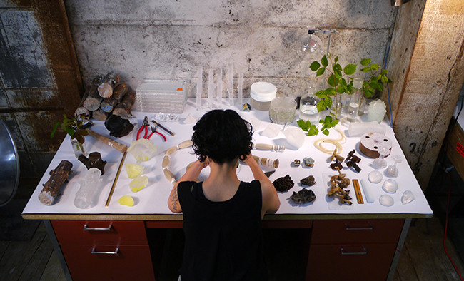Emily Nachison in the studio

