

300 NW 13th Avenue
Portland, OR 97209 USA
503-227-0222 phone
503-227-0008 fax
gallery@bullseyeglass.com
www.bullseyegallery.com

July 7, 2010 FOR IMMEDIATE RELEASE

Invisible Cities
Artists Carrie Iverson, Richard Parrish, Nathan Sandberg and Jeffrey Sarmiento respond to Italo Calvino's Invisible Cities.

When: Wednesday, August 4 – Saturday, September 25, 2010
Tuesday – Saturday, 10:00 am – 5:00 pm
(and by appointment)

Where: Bullseye Gallery
300 NW 13th Avenue
Portland, OR 97209 USA
View map

Reception: Wednesday, August 4, 5:30 – 7:30 pm

First Thursday: August 5, open until 8:00 pm
September 2, open until 8:00 pm

Portland, OR – Bullseye Gallery presents a group exhibition of individual and collaborative works based on Italian author Italo Calvino’s Invisible Cities, on view August 4 through September 25, 2010.

In a series of stories told by Marco Polo to the aging emperor Kublai Khan, Calvino describes fifty-five cities whose structures, cultures and existence stretch the boundaries of reality. The Invisible Cities exhibition responds to Calvino's work through exploration of urban themes that are distinct yet intertwined.

The number of cities that include ghosts, mirrors or doubles intrigued Carrie Iverson, whose work often explores the internal structures of the body and buildings. "I became particularly interested," Iverson explains, "in the liminal area, the threshold or border where those reflective cities meet". Nathan Sandberg's work references repetition and structure. His interest lies in "the parts of the city that exist in the middle, between where you drive and walk." To Sandberg, this often-ignored arrangement suggests a never-ending structure that links all cities. "As you arrive in a new location," he continues, "it starts all over again; the color of paint may change and the surfaces may shift." Richard Parrish's layered works reference topographical elevations and explore the idea of "maps as layered memory of both past and future places". Parrish notes, "as an architect I should be interested in the cities... but I find that I am most intrigued by the journey." Jeffrey Sarmiento also draws inspiration from mapping. His maps, however, relate more to ethnography than place. The maps "don't always point from one place to another," explains Sarmiento, "instead, the works show a cultural terrain." Drawing on the striking and perplexing imagery from the novel, Sarmiento creates worlds that are as familiar as they are foreign.

To view artwork online or download artist statements and CVs, please visit www.bullseyegallery.com. To request high-resolution images or to schedule an interview, please contact Michael Endo: michaelendo@bullseyeglass.com; 503-227-0222.
# #
About the gallery: Bullseye Gallery offers contemporary art objects and experiences examining the potential and complexity of kilnformed glass. The gallery is part of Bullseye Glass Company, a maker of glass for art and architecture since 1974.
# # #

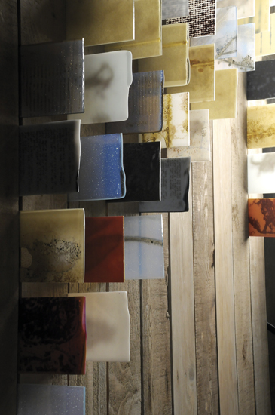

Carrie Iverson and Nathan Sandberg, Synchronicity, 2010
kilnformed glass, wood, paint.
96 x 252 x 7.5 inches
Photo: J. Sayer, Image courtesy of Bullseye Gallery

