

300 NW 13th Avenue
Portland, OR 97209 USA
503-227-0222 phone
503-227-0008 fax
gallery@bullseyeglass.com
www.bullseyegallery.com

August 25, 2008 FOR IMMEDIATE RELEASE

Silvia Levenson: It's Not Living Alone…
Wire-punctured glass furniture and kilnformed glass housewares portray a dark domesticity

When: September 23 – December 6, 2008
Tuesday – Saturday, 10:00 am – 5:00 pm
(and by appointment)

Where: Bullseye Gallery
300 NW 13th Avenue
Portland, OR 97209 USA
View map

First Thursday: October 2, open until 8:00 pm
November 6, open until 8:00 pm
December 4, open until 8:00 pm

Portland, OR - Bullseye Gallery is proud to present Silvia Levenson’s darkly-tinted vision of modern home life in, It’s Not Living Alone…, which will be exhibited from September 23 – December 6, 2008.

“It’s not living alone,” writes Portland author Chuck Palahniuk, “if you sleep with a rifle under the bed.” In her recent body of work, Levenson takes this quote as a starting point from which to subvert our ideas about the ‘domestic’. Levenson believes that “we imagine our houses as shells that isolate and protect us from the outside world.” However, as she reminds us, “the home can become a battlefield where we go to war with the very people we know so well.”

Levenson claims “furniture can speak volumes about human relationships.” As she explains, “We project our personal experiences, desires and memories onto these everyday objects, each of which contribute to our shared idea of ‘home’. Houses around the world are filled with identical IKEA furniture; in New York, Rome, Paris, Amsterdam, Berlin, Sydney, or Barcelona we can sit and relax in the same armchairs and eat at the same tables.”

“In my installations,” explains Levenson, “I modify the common ‘skin’ of the objects, covering them with iridescent glass tiles punctuated with copper wire. These pieces refer to the fragility of the home and the impossibility of finding repose. By transforming the gallery into a house, I confront my own expectations of happiness and safety. In this body of work, I create a frozen domesticity, exploring the structures and layers of daily life. Visitors become voyeurs. I show what usually is hidden. I say aloud what usually is whispered.”

Originally from Buenos Aires, Argentina, Levenson immigrated to Italy in 1981, during the "disappearances" of the Dirty War. Levenson has had a strong career as an educator, leading workshops and courses at glass programs and museums in Scotland, Australia, Germany, Italy, Argentina and the US. In 2004, Levenson received the Rakow Commission award from the Corning Museum of Glass in Corning, NY. This year, she was a shortlisted nominee for the 2008 Bombay Sapphire Prize. Her work is a part of public collections around the world, including the Corning Museum of Glass (US), the Museo del Vidrio (Argentina), the Museo del Vetro (Italy), and the Glasmuseet Ebeltoft (Denmark).

To view artwork online or download artist statements and CVs, please visit www.bullseyegallery.com. To request additional information or high-resolution images, please contact Patrick Leonard: patrickleonard@bullseyeglass.com; 503-227-0222. To schedule an interview, please contact Jamie Truppi: jamietruppi@bullseyeglass.com; 503-227-0222.
About the gallery: Bullseye Gallery works with a select group of international artists with the aim of furthering exceptional design in glass through innovation in material and method. The gallery is part of Bullseye Glass Company, a maker of colored glass for art and architecture since 1974.
###
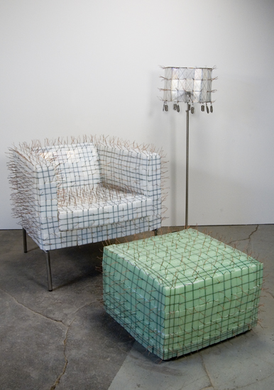
Silvia Levenson
Clockwise from left: Everything is OK (Armchair), Luce Dei Miei Occhi (Standing Lamp), and Life is Wonderful (Pouf), 2008
kilnformed glass, wire, chair, ottoman, lamp
approximately 50 x 51 x 70 inches installed
Photo: P. Leonard

