

300 NW 13th Avenue
Portland, OR 97209 USA
503-227-0222 phone
503-227-0008 fax
gallery@bullseyeglass.com
www.bullseyegallery.com

August 29, 2009 FOR IMMEDIATE RELEASE

Jessica Loughlin: Expanse
Serene, abstract glass works inspired by the Australian landscape

When: September 29 - November 21, 2009
Tuesday – Saturday, 10:00 am – 5:00 pm
(and by appointment)

Where: Bullseye Gallery
300 NW 13th Avenue
Portland, OR 97209 USA
View map

Artist Reception: Wednesday, September 30, 5:30 – 7:30 pm

First Thursday: October 1, open until 8:00 pm
November 5, open until 8:00 pm

Portland, OR - Bullseye Gallery is pleased to announce its third solo exhibition of work by Jessica Loughlin. Since her first show at Bullseye over a decade ago, Loughlin has established herself as one of Australia’s most frequently awarded young artists in the field of contemporary studio glass.

“Expanse” continues Loughlin’s ever-evolving exploration of the relationship between exterior space and interior experience. “To me, the Australian landscape is defined by its vast space… There is an inherent quiet and stillness,” explains Loughlin. “It is portraying this stillness that has remained a constant aim within my work.”

Inspired by time spent at Lake Gairdner, Australia’s fourth largest salt lake, Loughlin is aiming at the experience rather than the image of the landscape. “I felt the most overwhelming sense of space – no activity or noise – just salt and sky,” she writes. “The boundary between air, water, and ground blurred. Light became the landscape, and I looked down into the sky.”

Jessica Loughlin received the Tom Malone Prize from the Art Gallery of Western Australia in 2004 and 2007 and was the 2001 winner of the Outstanding New Artist in Glass award from UrbanGlass. Her work is included in the permanent collections of the Glasmuseet Ebeltoft in Denmark, the National Gallery of Australia in Canberra and the Victoria and Albert Museum in London.

To view artwork online or download artist statements and CVs, please visit www.bullseyegallery.com. To request high-resolution images or to schedule an interview, please contact Ryan Watson: ryanwatson@bullseyeglass.com; 503-227-0222.

About the gallery: Bullseye Gallery works with a select group of international artists with the aim of furthering exceptional design in glass through innovation in material and method. The gallery is part of Bullseye Glass Company, a maker of colored glass for art and architecture since 1974.
###
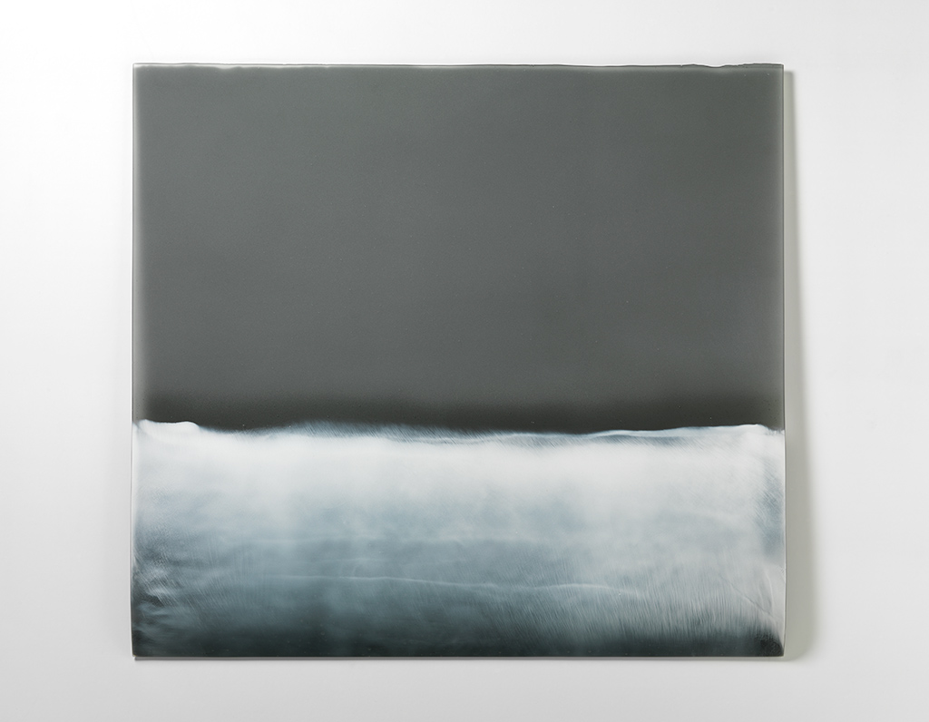
Jessica Loughlin, Residuum 2, 2009
kilnformed glass, 34.25 x 31 x 1 inches
Photo: Grant Hancock
Image Courtesy of Bullseye Gallery

