

300 NW 13th Avenue
Portland, OR 97209 USA
503-227-0222 phone
503-227-0008 fax
gallery@bullseyeglass.com
www.bullseyegallery.com

May 1, 2009 FOR IMMEDIATE RELEASE

Klaus Moje
Master glass artist returns to Portland for a survey show

When: June 30 – August 22, 2009
Tuesday – Saturday, 10:00 am – 5:00 pm
(and by appointment)

Where: Bullseye Gallery
300 NW 13th Avenue
Portland, OR 97209 USA
View map

Reception: July 1, 5:30 – 7:30 pm

First Thursday: July 2, open until 8:00 pm
August 6, open until 8:00 pm

Portland, OR – Bullseye Gallery is pleased to present the bold and trailblazing art of glass master Klaus Moje. On display from June 30 – August 22, 2009, the exhibit will feature pieces spanning three decades of the artist’s diverse artistic output. This work will be on view concurrently with the run of Klaus Moje’s retrospective at the Museum of Art and Design (MAD) in New York, which grew out of last summer’s lauded exhibition held at the Portland Art Museum.

Few artists have had such a broad and clear impact on the development of a medium as Klaus Moje has had on kilnformed glass. In 1983, Klaus Moje founded what would become Australia’s premier center for talent in glass art: the Glass Workshop at the Canberra School of Art, Australian National University. Over the last 26 years, Canberra has earned accolades for the success of its graduates and their high standing among collectors of contemporary studio glass.

Moje’s impact, however, has extended beyond generations of students to influence the actual materials of his practice. Inspired by Moje's groundbreaking methods, the founders of Bullseye Glass Company developed testing methods and formulas that could withstand the stresses of the artist's new kilnforming techniques. This, in turn, led to a three-decade friendship and collaboration between Moje and Bullseye that culminated, in 2007, with the creation of the monumental and medium-defying Portland Panels: Choreographed Geometry, which is the centerpiece of the MAD retrospective.
As Moje’s primary gallery in the United States, Bullseye Gallery will showcase a diverse selection of art from Moje’s prolific career. While the pieces represent many different bodies of work, they all capture Moje’s characteristically saturated colors and abstract patterns, which range from rigidly geometric to remarkably fluid. The Portland exhibit will be a special opportunity for West Coast audiences to experience the work of this unparalleled artist on the occasion of his New York retrospective.
##

To view artwork online or download artist statements and CVs, please visit www.bullseyegallery.com. To request additional information or high-resolution images, please contact Patrick Leonard: patrickleonard@bullseyeglass.com; 503-227-0222. To schedule an interview, please contact Jamie Truppi: jamietruppi@bullseyeglass.com; 503-227-0222.

About the gallery: Bullseye Gallery works with a select group of international artists with the aim of furthering exceptional design in glass through innovation in material and method. The gallery is part of Bullseye Glass Company, a maker of colored glass for art and architecture since 1974.
###
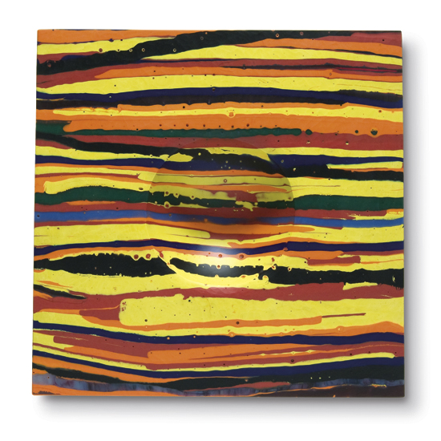

Klaus Moje
Untitled 3, 1994 (#7)
1994
kilnformed and coldworked glass
15.5 x 15.625 x 2.25 inches
Photo: P. Leonard
Image courtesy of Bullseye Gallery

