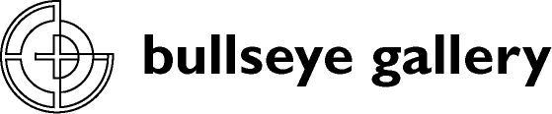

300 NW 13th Avenue
Portland, OR 97209 USA
503-227-0222 phone
503-227-0008 fax
gallery@bullseyeglass.com
www.bullseyegallery.com

November 26, 2010 FOR IMMEDIATE RELEASE

Klaus Moje: Constructed
Bullseye is proud to present recent works by studio glass master Klaus Moje.

When: December 1, 2010 – January 22, 2011
Tuesday – Saturday, 10:00 am – 5:00 pm
(and by appointment)

Where: Bullseye Gallery
300 NW 13th Avenue
Portland, OR 97209 USA
View map

First Thursday: December 2, open until 8:00 pm
January 6, open until 8:00 pm

Portland, OR – Klaus Moje exhibits bold pattern and saturated color in Constructed, a solo exhibition on view from December 1, 2010 - January 22, 2011. Following last year's retrospective at the Museum of Arts and Design in New York, Moje brings his deep understanding of color and composition to human-scale kilnformed wall panels. Influenced by the Bauhaus, Moje's oeuvre is an exploration of color and form recalling geometric abstraction and op art, but it adheres to neither. Moje opts for a combination of simple, contemplative form and visceral visual experience.

Few artists have had such a broad and clear impact on the development of a medium as Klaus Moje on kilnformed glass. In 1983, Klaus Moje founded what would become Australia’s premier center for talent in glass art: the Glass Workshop at the Canberra School of Art, Australian National University. Over the last 27 years, Canberra has earned accolades for the success of its graduates and their high standing among collectors of contemporary studio glass.

Moje’s impact, however, has extended beyond generations of students to influence the actual materials of his practice. Inspired by Moje's groundbreaking methods, the founders of Bullseye Glass Company developed testing methods and formulas that could withstand the stresses of the artist's new kilnforming techniques. This, in turn, led to a three-decade friendship and collaboration between Moje and Bullseye that culminated in 2007 with the creation of the monumental and medium-defying Portland Panels: Choreographed Geometry, which was the centerpiece of his retrospectives at the Portland Art Museum in 2008 and the Museum of Arts and Design, New York, in 2009.
##
To view artwork online or download artist statements and CVs, please visit www.bullseyegallery.com. To request high-resolution images or to schedule an interview, please contact Michael Endo: michaelendo@bullseyeglass.com; 503-227-0222.

About the gallery: Bullseye Gallery offers contemporary art objects and experiences examining the potential and complexity of kilnformed glass. The gallery is part of Bullseye Glass Company, a maker of glass for art and architecture since 1974.
###
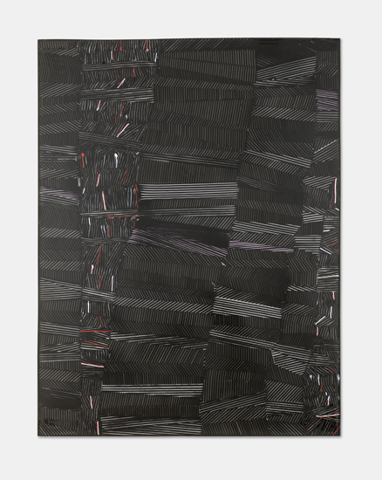

Klaus Moje
Constructed 2
2010
kilnformed and coldworked glass
46.25 x 35.25 x 1.25 inches
Photo: R. Little
Image courtesy of Bullseye Gallery

