

300 NW 13th Avenue
Portland, OR 97209 USA
503-227-0222 phone
503-227-0008 fax
gallery@bullseyeglass.com
www.bullseyegallery.com

August 11, 2009 FOR IMMEDIATE RELEASE

Catharine Newell: Interstice
Portland artist Catharine Newell explores the spaces between things that gather, swarm, and flock.

When: September 1 – October 24, 2009
Tuesday – Saturday, 10:00 am – 5:00 pm
(and by appointment)

Where: Bullseye Gallery
300 NW 13th Avenue
Portland, OR 97209 USA
View map

Artist Reception: September 2, 5:30 – 7:30 pm

First Thursday: September 3, open until 8:00 pm
October 1, open until 8:00 pm

Portland, OR - Bullseye Gallery is pleased to present an exhibition featuring new works by Portland artist Catharine Newell. Exploring the dynamics of swarm intelligence in the medium of kilnformed glass, Interstice will be on view from September 1 – October 24, 2009.

“Standing alone on a windswept Caithness cliff compelled me to recognize what a singular existence mine is,” says Newell. Her journey to northern Scotland led her to “examine the phenomenon of singularity within communal living.”

Of particular interest to Newell is “the dynamics involved in swarm intelligence.” “Decentralized control, perceptive response to local cues, and simple rules of thumb,” she explains; “add up to a startlingly effective strategy toward attaining collective goals that serve the interests of an entire community.”

Selected by Western Art & Architecture in Fall 2008 as “One to Watch,” Newell has been chosen twice by Corning Museum of Glass for their annual New Glass Review. In March 2008, Oregon Public Broadcasting featured a televised profile of the artist on “Art Beat.” Newell’s work can be found in the permanent collections of the Academy of Arts and Design at Tsinghua University in Beijing, China, the Hotel Murano in Tacoma, Washington, and the Hunter Museum of American Art in Chattanooga, Tennesee.

To view artwork online or download artist statements and CVs, please visit www.bullseyegallery.com. To request additional information or high-resolution images, please contact Ryan Watson: ryanwatson@bullseyeglass.com; 503-227-0222. To schedule an interview, please contact Jamie Truppi: jamietruppi@bullseyeglass.com; 503-227-0222.

About the gallery: Bullseye Gallery works with a select group of international artists with the aim of furthering exceptional design in glass through innovation in material and method. The gallery is part of Bullseye Glass Company, a maker of colored glass for art and architecture since 1974.
###
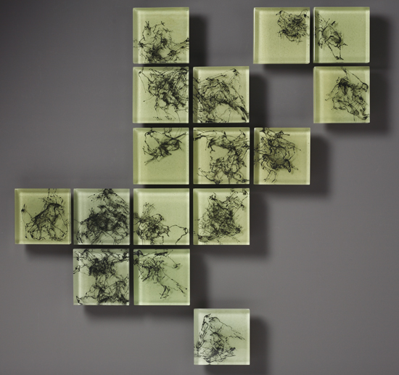
Catharine Newell, Scat, 2008
kilnformed glass, 37.375 x 37.5 x 2 inches installed
Photo: Paul Foster

