PRESS RELEASE PRESS RELEASE PRESS RELEASE PRESS RELEASE

Portland Center for the Performing Arts Launches Visual Arts Program

Portland Art Dealers Association Contributes First Exhibition in ArtBar Series

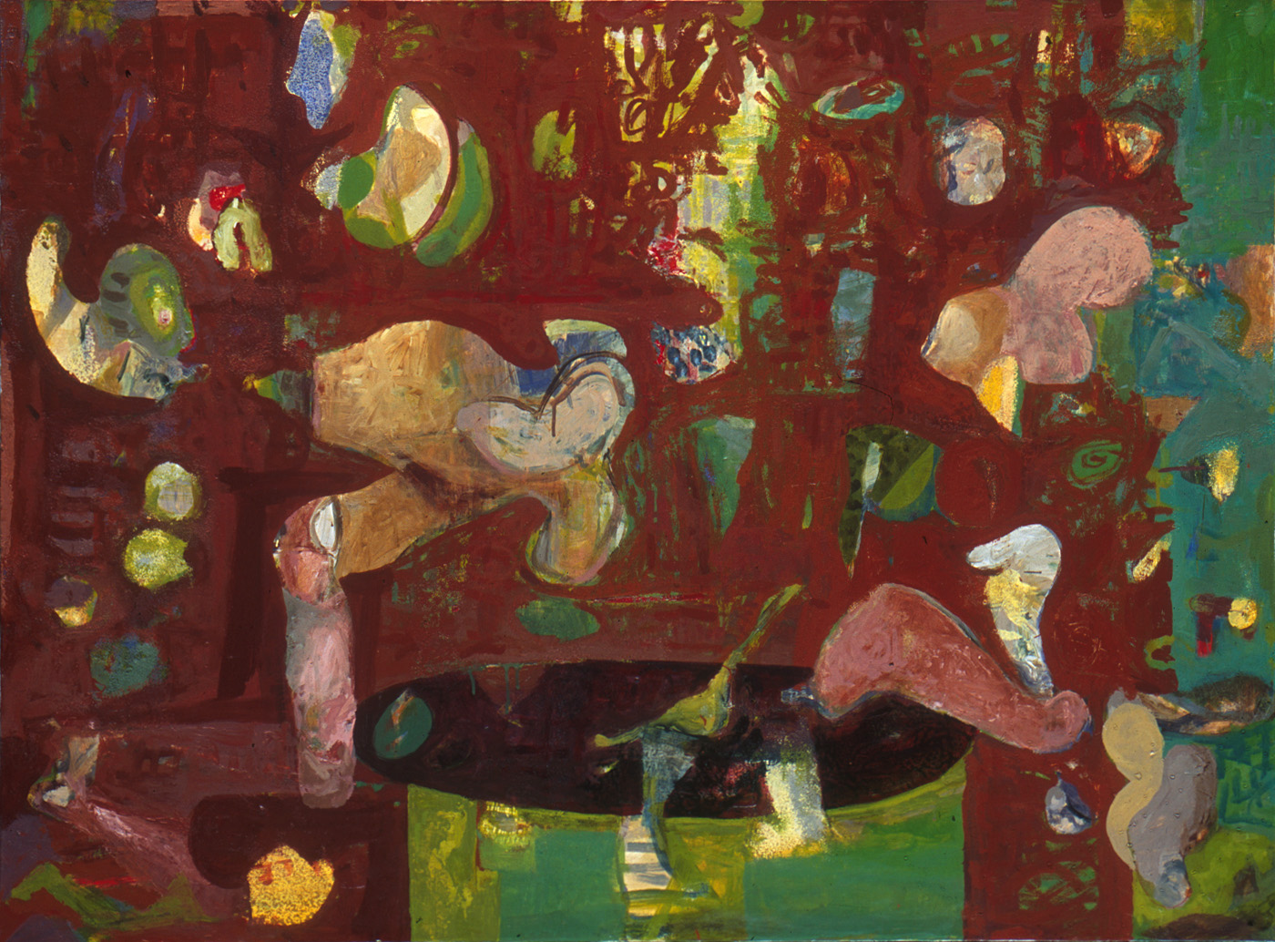

Drake Deknatel, Dutch Window, 2002, aliphatic urethane & pigment, 44 x 60 inches.
Courtesy of Elizabeth Leach Gallery

Exhibition Dates: November 21, 2005 – January 28, 2006
Opening Reception: First Thursday, December 1, 2005, 6 – 9 pm
Location: The ArtBar, PCPA Rotunda Lobby, 1111 SW Broadway, Portland OR 97205
Hours & Admission: Open to the public daily for viewing, free of charge.

Portland, OR (Thursday, November 17, 2005) - The Portland Center for Performing Arts (PCPA) is pleased to announce the first in an ongoing series of art exhibitions in the ArtBar, the destination for drinks and dining in the Rotunda Lobby of the Center, located at Broadway and Main. By collaborating with The Portland Art Dealers Association (PADA), the PCPA has solidified an eclectic and dynamic gathering of works for the initial installment of the series. The art exhibition will provide a sampling of the vast array of artistic genres represented by Portland’s thriving visual arts community, signaling a standard of excellence and diversity slated for future PCPA ArtBar exhibitions.

“We are excited to launch the new ArtBar exhibition program by collaborating with the Portland Art Dealer’s Association,” said Robyn Williams, executive director, PCPA. The talent demonstrated by artists affiliated with PADA galleries is extraordinary, “ Williams added.

The ArtBar exhibition program is an ongoing series designed to integrate the work of Portland artists, galleries, and curators into prominent PCPA venues. “We are accustomed to having fine performing art on our stages, and now our venue will be complimented by fine visual art as well,” Williams noted.
The ArtBar exhibition series is coordinated by an art sub committee of the PCPA Advisory Committee. The PCPA Advisory Committee is a citizen committee appointed by the City of Portland. The Committee provides advocacy and counsel for the Portland Center for the Performing Arts so it may effectively serve the region with responsibly managed, world-class performance arts venues.

Portland Center for the Performing Arts is the region’s premier performing arts venue management organization. Portland Center for the Performing Arts manages the Keller Auditorium, Arlene Schnitzer Concert Hall, and the New Theatre Building, housing the Winningstad Theatre, Newmark Theatre and Brunish Hall. Portland Center for the Performing Arts is managed by MERC, a subsidiary of Metro.

For added information, please contact:

Portland Center for the Performing Arts
Robyn Williams, Executive Director
503.274.6565

Exhibition Media Inquiries:
Erin Greeson
ering@gradybritton.com
503.228.4118

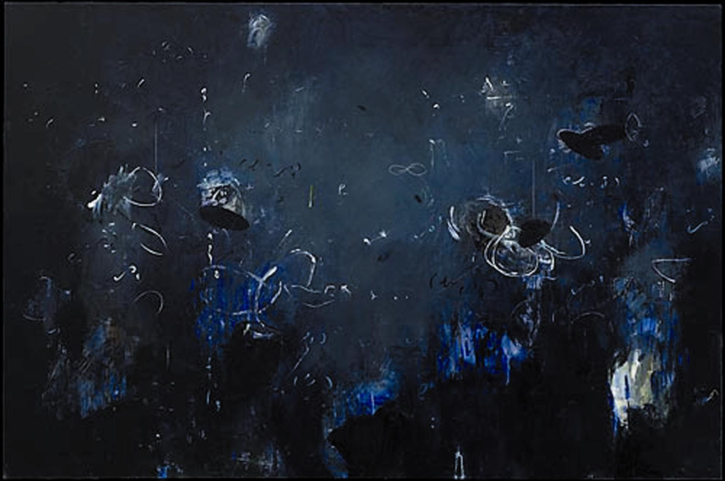

Michael Schultheis, Harmonic Oscillations 04, acrylic on canvas, 48 x 72 inches.
Courtesy of Charles Froelick Gallery

