

300 NW 13th Avenue
Portland, OR 97209 USA
503-227-0222 phone
503-227-0008 fax
gallery@bullseyeglass.com
www.bullseyegallery.com

March 10, 2010 FOR IMMEDIATE RELEASE

PHOTO/SYNTHESIS:
A panel discussion with three artists at the intersection of photography and contemporary glass

When: Tuesday, March 30, 2010
6:00 - 8:00 pm
Reception begins at 5:30 pm
RSVP required (503) 227-2797 or sales@bullseyeglass.com

Where: Bullseye Gallery
300 NW 13th Avenue
Portland, OR 97209 USA
View map

Portland, OR - Bullseye Gallery is pleased to host PHOTO/SYNTHESIS, a discussion with visual artists Carrie Iverson, April Surgent and Joanne Teasdale; moderated by arts critic Richard Speer, Tuesday, March 30, 2010.

Photography and glass are intimately linked through their relationship with light. Each medium relies on changing levels of transparency and opacity to define image and form. PHOTO/SYNTHESIS will explore this connection with a discussion between three artists that use both photography and glass in unique ways. Carrie Iverson uses photography as a sketchbook from which she culls the textures and ephemeral artifacts that make up the subtle imagery of her glass works. April Surgent's photographs capture fleeting, everyday moments. These moments are then solidified in glass through meticulous cameo-engraving. Joanne Teasdale was drawn to glass for its ability to tangibly express the intimacy that was exposed in her photographs.
Richard Speer has been visual arts critic at Portland’s alternative newsweekly, Willamette Week since 2002. His essays on art, architecture, and culture have appeared in Newsweek, The Los Angeles Times, The Chicago Tribune, Salon, and Opera News. He is also a contributing critic for ARTnews, art ltd., Visual Art Source, and GLASS Quarterly and the author of Matt Lamb: The Art of Success (John Wiley & Sons).

About the gallery: Bullseye Gallery works with a select group of international artists with the aim of furthering exceptional design in glass through innovation in material and method. The gallery is part of Bullseye Glass Company, a maker of colored glass for art and architecture since 1974.
###

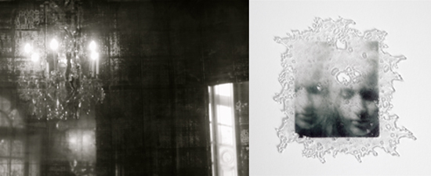
(left)
Joanne Teasdale, Visitation (detail), 2009
pigment print mounted on acrylic, 24 x 16 inches
(right)
Joanne Teasdale, Twins, 2010
fusible film and kilnformed glass, 9 x 9 x .5 inches
photo: John Vokoun
images courtesy of Bullseye Gallery

