

300 NW 13th Avenue
Portland, OR 97209 USA
503-227-0222 phone
503-227-0008 fax
gallery@bullseyeglass.com
www.bullseyegallery.com

May 15, 2008 FOR IMMEDIATE RELEASE

Clifford Rainey: Retrospective
Classical icons, contemporary society, and diverse cultural symbols collide in clever, allegorical sculptures.

When: June 10 - August 16, 2008
Tuesday – Saturday, 10:00 am – 5:00 pm
(and by appointment)

Where: Bullseye Gallery
300 NW 13th Avenue
Portland, OR 97209 USA
View map
Artist Reception: June 20, 6:00 – 9:00 pm.

First Thursday: July 3, open until 8:00 pm
August 7, open until 8:00 pm

Portland, OR - Bullseye Gallery is pleased to announce a retrospective of Irish-born artist Clifford Rainey’s allusive and provocative sculpture. The exhibition, which encompasses both recent and historic work, will be on view June 10 – August 16, 2008.

“I am inspired by my experiences,” says Rainey, “my daily experiences [and] my lifelong experiences.” Clifford Rainey has spent his life traveling the world, exploring regional ethnic groups and studying both cultural and artistic history. In the process, he has amassed a visual iconography that references forms and concepts as diverse as Greco-Roman sculpture and the current stresses of globalization. “[My] ideas tend to come in tiny increments that form a larger composition like a symphony,” he explains. As a result, his work is richly layered with double entendres and intriguing cultural convergences.

“Symbols mean a lot to me,” says Rainey, “I know why I put them there but I also want people to read them in their own way.” One such multi-faceted symbol is the ubiquitous Coca-Cola bottle, a modern icon that has become a running thread throughout much of Rainey’s work. “When you look at a Coca-Cola bottle,” he explains, “you think, ‘this is a very simple thing; it is trivial.’ But when you start to look into it, it grows and grows and becomes quite complicated. Warhol made that statement very simple. What I’m trying to do is take it ten times further”.

Rainey notes that all of his works “are sort of autobiographical.” “They are my attempt,” he says, “to try to understand the situation we’re in. One of my major conflicts, which has existed for a long time, is that I both absolutely adore human beings and I absolutely detest them, including myself. When you’re dealing with a lot of cultures I think what you’re trying to do is understand yourself.”

“My work is not meant to entertain,” Rainey declares, “but to challenge preconceived notions, to disturb and to be honest in its conception and execution.” This confrontational thread, clearly present in his concepts, also appears in his practice. In spite of his proficiency with glass and his keen draftsmanship, he is unafraid to push the sculptural potentials of his materials. He abrades and ages his work, removing the sheen of the glass, so that in the end, it more closely resembles archaeological relics than sculpture in a contemporary gallery. “The idea was if [my work] was ever found in the future, an archeologist might immediately identify it as being from four hundred years ago,” jokes Rainey. “That will really confuse them.”

After receiving his degree in 1973 from the Royal College of Art in London, Rainey served as a lecturer at the school from 1977 until 1984. Currently, Rainey is the Chair of the glass program at the California College of the Arts in Oakland, where he has taught since 1991. Rainey’s work is exhibited in numerous public collections, including the Victoria and Albert Museum in London, the Corning Museum of Glass in Corning, New York, the de Young Museum in San Francisco, and the Los Angeles County Museum of Art. In addition, Rainey has undertaken major public commissions in Saudi Arabia and throughout the UK.
##

To view artwork online or download artist statements and CVs, please visit www.bullseyegallery.com. To request additional information or high-resolution images, please contact Patrick Leonard: patrickleonard@bullseyeglass.com; 503-227-0222. To schedule an interview, please contact Jamie Truppi: jamietruppi@bullseyeglass.com; 503-227-0222.

About the gallery: Bullseye Gallery works with a select group of international artists with the aim of furthering exceptional design in glass through innovation in material and method. The gallery is part of Bullseye Glass Company, a maker of colored glass for art and architecture since 1974.
###

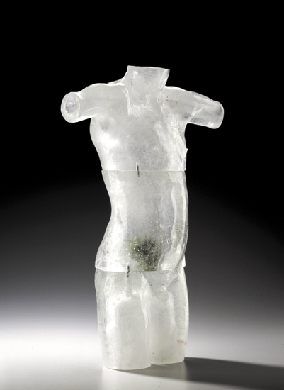

Clifford Rainey
Philosophical Boy - Job No. 4
2005
glass, ceramic apple, wire, pins, gesso, maple plinth
43.5 x 19 x 15 inches, including base (not pictured)
Photo: M. Lee Fatherree
Image courtesy of Bullseye Gallery

