

300 NW 13th Avenue
Portland, OR 97209 USA
503-227-0222 phone
503-227-0008 fax
gallery@bullseyeglass.com
www.bullseyegallery.com

November 13, 2009 FOR IMMEDIATE RELEASE

Mel George: Reminders
Interpretations of nostalgia take form in glass snapshots and calendars

When: December 1 - January 23, 2010
Tuesday – Saturday, 10:00 am – 5:00 pm
(and by appointment)

Where: Bullseye Gallery
300 NW 13th Avenue
Portland, OR 97209 USA
View map

Reception: Wednesday, December 2, 5:30 - 7:30pm

First Thursday: December 3, open until 8:00 pm
January 7, open until 8:00 pm

Portland, OR - Bullseye Gallery is pleased to present its first solo exhibition of work by Australian artist Mel George. After living in Portland, Oregon for over ten years, George recently returned to her native Australia. “Reminders,” on view December 1 - January 23, 2010, is an homage to the city of Portland.

George’s work investigates the relationship between her Australian and American identities. “My travels and time away,” says George, “have not only affected my perception of self, but the dynamics of my personal relationships and my description of ‘home’. It was only when I decided to leave that I really started to enjoy and love the city of Portland, the place I refused to call home.” The exhibition is a collection of kilnformed glasswork referencing Polaroids and calendars that are intimate reminders of the place she now calls her “second, yet equal, home.”

A graduate of Australian National University’s Canberra School of Art, George completed a residency at the Bullseye Glass factory in 1998, later returning to work for Bullseye’s Research and Education department on projects with international glass masters. After eight years of owning and operating Studio Ramp with her husband, artist Jeremy Lepisto, in Portland, the couple returned to George’s hometown of Canberra, Australia. She teaches and continues making and exhibiting her own work nationally and internationally.

To view artwork online or download artist statements and CVs, please visit www.bullseyegallery.com. To request high-resolution images or to schedule an interview, please contact Ryan Watson: ryanwatson@bullseyeglass.com; 503-227-0222.

About the gallery: Bullseye Gallery works with a select group of international artists with the aim of furthering exceptional design in glass through innovation in material and method. The gallery is part of Bullseye Glass Company, a maker of colored glass for art and architecture since 1974.
###
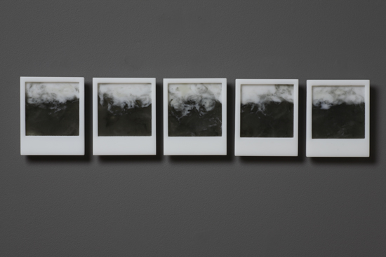
Mel George, Looming, 2009
kilnformed glass, 4.25 x 19 x .5 inches
Photo: Paul Foster
Image Courtesy of Bullseye Gallery

