

300 NW 13th Avenue
Portland, OR 97209 USA
503-227-0222 phone
503-227-0008 fax
gallery@bullseyeglass.com
www.bullseyegallery.com

February 9, 2009 FOR IMMEDIATE RELEASE

Michael Rogers: Flock
Hauntingly surreal cast-glass sculpture from artist and RIT professor Michael Rogers.

When: March 3 – April 11, 2009
Tuesday – Saturday, 10:00 am – 5:00 pm
(and by appointment)

Where: Bullseye Gallery
300 NW 13th Avenue
Portland, OR 97209 USA
View map

Artist Reception: March 4, 5:30 – 7:30 pm

First Thursday: March 5, open until 8:00 pm
April 2, open until 8:00 pm

Portland, OR - Bullseye Gallery is excited to announce an exhibition featuring the beautifully dark and Gothic sculpture of artist Michael Rogers. Filling the gallery with bound birds and ornate frames, Flock will be on view from March 3 – April 11, 2009.

“My work in glass reflects my interest in language, literature, transparency, and found objects,” says artist Michael Rogers. “I try to work with objects in the way poets work with words, combining words/objects in such a way as to create new or multiple meanings, more open to viewer or reader interpretations.”

Of particular interest to Rogers are “things seen and experienced that return to mind again and again.” “I think of this phenomenon as visual resonance,” Rogers explains; “travel, books read, people met, things seen and heard all return in the form of recollections.” “Perhaps making art,” he notes, “is my way of trying to hold on to the ephemera of daily life. There is something profound in even the slightest and most subtle of human experiences. Glass, with its transparency and translucency as a material, is at once there and not there, making it the perfect poetic material to try to capture the fleeting.”

After spending 11 years in Japan where he was head of Aichi University’s Glass Department, artist Michael Rogers returned to the United States where he is now a Professor in the College of Imaging Arts and Sciences at Rochester Institute of Technology in New York. Michael’s work can be found in the permanent collections of the Suntory Museum in Japan, the Contemporary Glass Art Museum of Alcorcon in Spain, Museo del Vidrio in Mexico, National Museum in Lviv, Ukraine, and the Corning Museum of Glass in the United States. He is currently finishing an artist residency at Osaka University of Arts.

To view artwork online or download artist statements and CVs, please visit www.bullseyegallery.com. To request additional information or high-resolution images, please contact Patrick Leonard: patrickleonard@bullseyeglass.com; 503-227-0222. To schedule an interview, please contact Jamie Truppi: jamietruppi@bullseyeglass.com; 503-227-0222.

About the gallery: Bullseye Gallery works with a select group of international artists with the aim of furthering exceptional design in glass through innovation in material and method. The gallery is part of Bullseye Glass Company, a maker of colored glass for art and architecture since 1974.
###

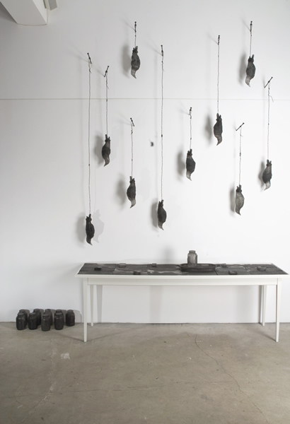

Michael Rogers, The Keeper’s Lament, 2008
cast glass, wood table, steel wire, 22 x 12 x 2 feet installed
Photo: E. Lamark

