

300 NW 13th Avenue
Portland, OR 97209 USA
503-227-0222 phone
503-227-0008 fax
gallery@bullseyeglass.com
www.bullseyegallery.com

October 22, 2009 FOR IMMEDIATE RELEASE

Bullseye at SOFA: CHICAGO
Building with Light: Contemporary Glass Art and Architecture
SOLO at SOFA: Klaus Moje

When: November 6-8, 2009
Friday & Saturday, 11:00 am – 8:00 pm
Sunday, 12:00 pm – 6:00 pm

Where: Festival Hall, Navy Pier
600 E. Grand Ave
Chicago, IL 60611

More Info: www.sofaexpo.com

Chicago, IL – Bullseye Gallery is pleased to present Building with Light: Contemporary Glass Art and Architecture as well as a solo exhibit by Klaus Moje at this year’s SOFA CHICAGO, the International Sculpture Objects and Functional Art Fair at Navy Pier, November 6-8, 2009.

Building with Light will showcase a new direction for Bullseye – to bring an artist’s perspective into the design of our interior spaces. Jessica Loughlin, Michael Rogers, Catharine Newell, Ted Sawyer, and Giles Bettison have been working with the Bullseye studio team, translating the artist’s vision into kiln glass stair treads, space dividers, and functional surfaces. The booth will feature the result of each artist’s design alongside the artwork that inspired its making.

Few artists have had such a broad and clear impact on the development of a medium as Klaus Moje has had on kilnformed glass. For SOLO at SOFA, Bullseye Gallery will showcase artwork that spotlights the aesthetic diversity of the artist’s career, including a selection of works from his most recent exhibitions at the Portland Art Museum (2008) and the Museum of Arts and Design (2009) in New York.

To view artwork online or download artist statements and CVs, please visit www.bullseyegallery.com. To request high-resolution images or to schedule an interview, please contact Ryan Watson: ryanwatson@bullseyeglass.com; 503-227-0222.

About the gallery: Bullseye Gallery works with a select group of international artists with the aim of furthering exceptional design in glass through innovation in material and method. The gallery is part of Bullseye Glass Company, a maker of colored glass for art and architecture since 1974.

About the fair: Celebrating its 16th year, SOFA CHICAGO 2009, the critically acclaimed Sculpture Objects & Functional Art Fair, returns to Navy Pier's Festival Hall (600 E. Grand Avenue) Nov. 6 - 8 to present masterworks from 68 top international galleries and dealers from 10 countries. Debuting this year is SOLO at SOFA, defined spaces where galleries will spotlight bodies of works on the cutting-edge by individual artists as well as object groupings.

###

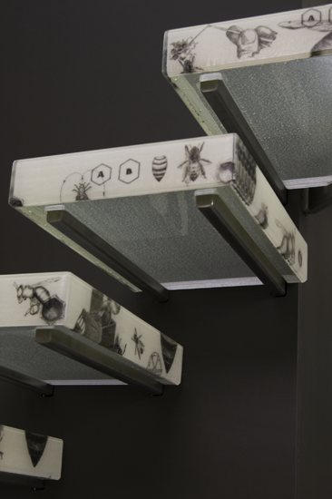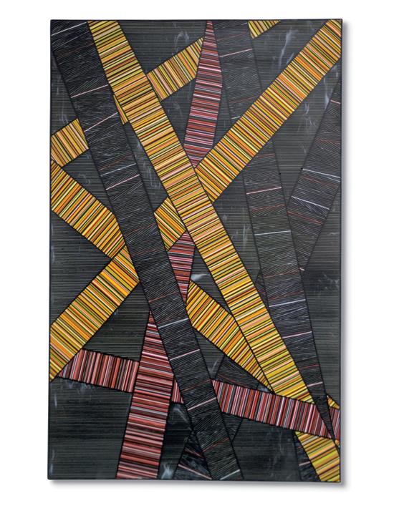

Kilnformed glass stair treads by Klaus Moje, The Portland Panels, 2007
Bullseye studio team + Michael Rogers kilnformed and diamond-polished glass
Photo: Ryan Watson 72 x 48 inches
Image Courtesy of Bullseye Gallery Photo: Ryan Watson
Image Courtesy of Bullseye Gallery

