

300 NW 13th Avenue
Portland, OR 97209 USA
503-227-0222 phone
503-227-0008 fax
gallery@bullseyeglass.com
www.bullseyegallery.com

April 28, 2009 FOR IMMEDIATE RELEASE

Bullseye at SOFA WEST: SANTA FE

When: June 11-14, 2009
Thursday - Sunday, 12:00 pm – 6:00 pm

Where: Santa Fe Convention Center
201 W. Marcy Street
Santa Fe, NM 87501

More Info: www.sofaexpo.com/santafe

Santa Fe, NM – Bullseye Gallery is pleased to exhibit at SOFA WEST: SANTA FE, the International Sculpture Objects and Functional Art Fair at the Santa Fe Convention Center, June 11-14, 2009. For SOFA’s inaugural fair in Santa Fe, Bullseye will be showing works by three internationally-recognized artists: Heike Brachlow (Germany/UK), Silvia Levenson (Argentina/Italy), and Jessica Loughlin (Australia). Whether up-and-coming, like Brachlow, or already established as exhibitors and educators, like Loughlin and Levenson, these three individuals represent the vanguard of glass as an artistic medium.

By re-fashioning house wares and pharmaceuticals in candy-colored glass, Silvia Levenson’s sculpture presents a dark and comic vision of modern home life. Originally from Buenos Aires, Argentina, Levenson immigrated to Italy in 1981, during the "disappearances" of the Dirty War. In 2004, Levenson received the Rakow Commission Award from the Corning Museum of Glass in New York and in 2008 she was a shortlisted nominee for the Bombay Sapphire Prize. Her work is a part of the collections of the Corning Museum of Glass, the Museo del Vidrio in Argentina, and the Museo del Vetro in Italy. Along with Loughlin, Levenson’s work was featured in Flux, the New Mexico Museum of Art’s first-ever glass art exhibition, held in 2008. The museum has since acquired works from the exhibit by both artists for its permanent collection.

Drawing inspiration from the landlocked salt lakes of her native Australia, Loughlin creates an illusory sense of depth in her quiet horizons of glass powders and cast layers. Loughlin received the Tom Malone Prize from the Art Gallery of Western Australia in 2004 and 2007 and was the 2001 winner of the Outstanding New Artist in Glass award from Urban Glass. Her work is included in the permanent collections of the Glasmuseet Ebeltoft in Denmark, the National Gallery of Australia, and the Victoria and Albert Museum.
As a part of Bullseye’s dedication to exposing the work of emerging artists to new audiences, the gallery is excited to be bringing work by Heike Brachlow. Formally refined, yet deliberately precarious, her sculpture directly engages the viewer with its kinetic qualities. Her work balances imposing and luminous cast forms atop one another, inviting the viewer to touch, whether boldly or guiltily. Born and raised in Munich, Germany, Brachlow received her MA in 2006 from the Royal College of Art in London and is currently pursuing doctoral work on color in glass, for which she received an Arts and Humanities Research Award. Brachlow was one of the most exciting finalists in the 2008 e-merge competition for new talent in glass.

To view artwork online or download artist statements and CVs, please visit www.bullseyegallery.com. To request additional information or high-resolution images, please contact Patrick Leonard: patrickleonard@bullseyeglass.com; 503-227-0222. To schedule an interview, please contact Jamie Truppi: jamietruppi@bullseyeglass.com; 503-227-0222.

About the gallery: Bullseye Gallery works with a select group of international artists with the aim of furthering exceptional design in glass through innovation in material and method. The gallery is part of Bullseye Glass Company, a maker of colored glass for art and architecture since 1974.
###
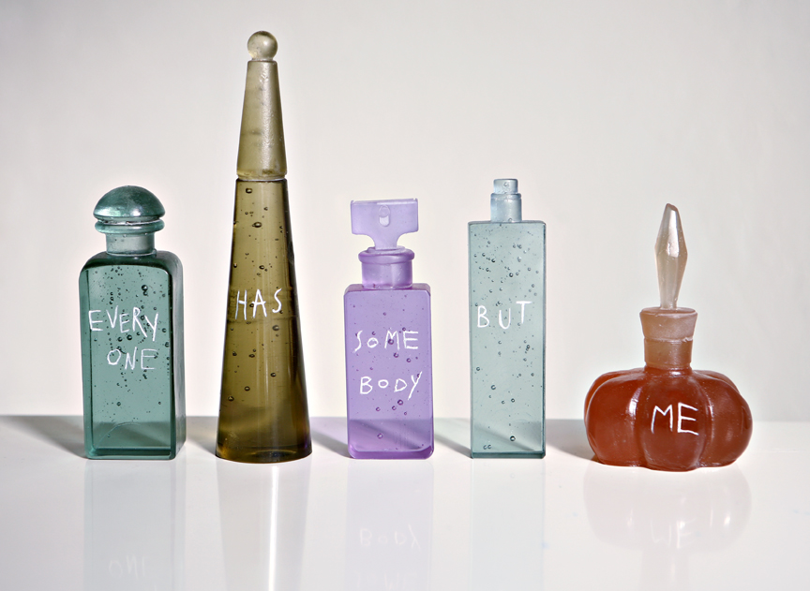
Silvia Levenson, Everyone Has Somebody But Me, 2009
kilncast glass, 8.25 x 13.75 x 2 inches installed
Photo: Endos.it
Image courtesy of Bullseye Gallery

