

300 NW 13th Avenue
Portland, OR 97209 USA
503-227-0222 phone
503-227-0008 fax
gallery@bullseyeglass.com
www.bullseyegallery.com

July 16, 2008 FOR IMMEDIATE RELEASE

Jeffrey Sarmiento: Translations
Contested cultural identities and architectural silhouettes juxtaposed in silkscreened glass.

When: August 12 – September 27, 2008
Tuesday – Saturday, 10:00 am – 5:00 pm
(and by appointment)

Where: Bullseye Gallery
300 NW 13th Avenue
Portland, OR 97209 USA
View map

First Thursday: September 4, open until 8:00 pm

Portland, OR - Bullseye Gallery is pleased to present the graphic and richly layered artwork of Jeffrey Sarmiento. The exhibition, Translations, will be on view from August 12 – September 27, 2008.

Throughout his career, artist Jeffrey Sarmiento has mined his family history for inspiration, juxtaposing it with his personal experience of ethnicity. “The tension between the inherited and the constructed activates my work,” he explains. “My work is an exploration of cultural roots through a strategy of self-imposed mismatches. The expression of my Filipino American heritage remains a constant, but I manipulate and remix this identity though new contexts. I intentionally work far from home to find new geographies, histories and languages. My attempts at assimilation force both a change in perspective as well as a reinforcement of held beliefs and values.”

Much of Sarmiento’s artwork takes the form of books and encyclopaedia volumes. By using glass as the medium upon which the information is printed,” he explains, “I am able to compose and rearrange content to create new visual statements. Complex readings of the image are made possible through fusion, transparency and optics.”

Sarmiento’s studies and teaching have taken him around the world, providing him with new cultural contexts to explore. After a recent trip through the Baltic States, he began a graphic response to the crumbling concrete and steel facades of the former Soviet occupation. “These forms,” he explains, “are re-presented as glass sculptures that utilize kilnforming and digital cutting for sharp and angular architectural interpretations. Through the refinement of works derived from old Soviet forms, [I] signal a new cultural perspective for [myself], as well as a celebration of a new era in Baltic society.”

Sarmiento pursued his education at the University of Illinois at Urbana-Champaign, and later at the Rhode Island School of Design, where he also taught. He has received accolades and fellowships from UrbanGlass (Brooklyn, NY), the Creative Glass Center of America (Millville, NJ), Pilchuck Glass School (Stanwood, WA), and the Fulbright Fellowship to Denmark. Most recently, his work was shortlisted as a finalist for the 2008 Bombay Sapphire Prize. Currently, Sarmiento is an instructor at the University of Sunderland in England as a part of his Research Councils UK Academic Fellowship in Glass for 2006-2011. His work is included in the collections of the Glasmuseet Ebeltoft (Denmark), the Museum of American Glass (Millville, NJ), and the Rhode Island School of Design Artist Book Collection (Providence, RI).

To view artwork online or download artist statements and CVs, please visit www.bullseyegallery.com. To request additional information or high-resolution images, please contact Patrick Leonard: patrickleonard@bullseyeglass.com; 503-227-0222. To schedule an interview, please contact Jamie Truppi: jamietruppi@bullseyeglass.com; 503-227-0222.

About the gallery: Bullseye Gallery works with a select group of international artists with the aim of furthering exceptional design in glass through innovation in material and method. The gallery is part of Bullseye Glass Company, a maker of colored glass for art and architecture since 1974.
###
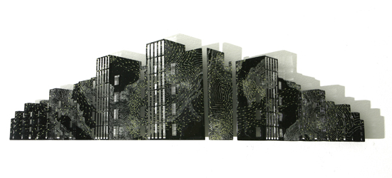
Jeffrey Sarmiento, Tower Block I, 2008
enameled and cast glass, 9.875 x 34.5 x 1.25 inches installed
Photo: David Williams

