

300 NW 13th Avenue
Portland, OR 97209 USA
503-227-0222 phone
503-227-0008 fax
gallery@bullseyeglass.com
www.bullseyegallery.com

July 25, 2007 FOR IMMEDIATE RELEASE

Bullseye presents Ted Sawyer: and yet

When: August 9 - September 29, 2007
Tuesday – Saturday, 10:00 am – 5:00 pm
(and by appointment)

Where: Bullseye Gallery
300 NW 13th Avenue
Portland, OR 97209 USA
View map

Artist Talk: Wednesday, August 16, 5:30 - 7:30 pm

First Thursday: September 6, open until 8:00 pm

Portland, OR - Bullseye Gallery is pleased to announce a solo exhibition by Ted Sawyer, who creates scarred-yet-appealing abstract works in kilnformed glass. The exhibition, “and yet,” will be on view August 9 - September 29, 2007.

“The world can be difficult, full of disconnection, wounds and roughshod repair jobs," says Sawyer. "But there are powerful forces like love and beauty that can change the world for the better. Beauty reveals the tremendous good fortune that we have in living, even when it is painful, sometimes especially when it is painful. This kind of beauty is not always obvious: it is found within the disfigured, ignored, and marginalized. In our culture we often create holes in ourselves that blind us to beauty and suck away the light. And yet there is still beauty and light.”

Sawyer, whose early training was in ceramics, heads Bullseye Glass Company's Research and Education Department where he works with international masters and emerging artists in translating their concepts into glass.

During factory residencies, artists work with Bullseye technicians at the R & E Department's studios. These projects, usually with artists whose backgrounds are in other media, often result in new techniques and materials. Bullseye Gallery, a showcase for exemplary work in glass, is the exclusive dealer of the finished works from these residencies.

To view Sawyer’ works online or download the artist’s statement and CV, please visit www.bullseyegallery.com.

To receive additional information, request high-resolution images, or schedule an interview, please contact Nicole Leaper: nicoleleaper@bullseyeglass.com;
503-227-0222.

About the gallery: Bullseye Gallery works with a select group of international artists with the aim of furthering exceptional design in glass through innovation in material and method. The gallery is part of Bullseye Glass Company, a maker of colored glass for art and architecture since 1974.

###

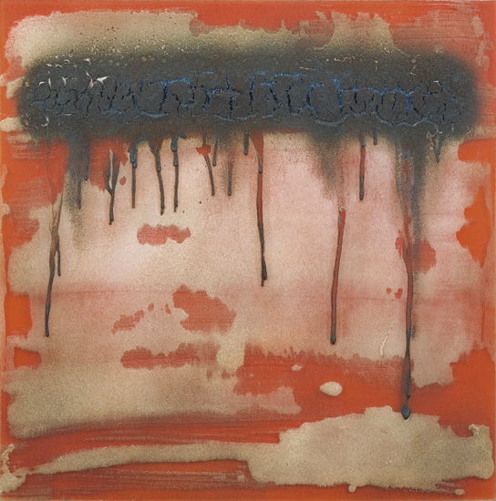

Ted Sawyer, Come Back III, 2007
kilnformed glass, 24.125 x 24 x .5 inches
Photo: J. Sayer

