

300 NW 13th Avenue
Portland, OR 97209 USA
503-227-0222 phone
503-227-0008 fax
gallery@bullseyeglass.com
www.bullseyegallery.com

September 27, 2007 FOR IMMEDIATE RELEASE

To Murano
Glass artwork selected by Tessa Papas for Tacoma’s Hotel Murano

When: October 4 – December 22, 2007
Tuesday – Saturday, 10:00 am – 5:00 pm
(and by appointment)

Where: Bullseye Gallery
300 NW 13th Avenue
Portland, OR 97209 USA
View map

First Thursday: October 4, open until 8:00 pm
November 1, open until 8:00 pm

Portland, OR – Bullseye Gallery is pleased to present To Murano, Portland’s opportunity to view glass artwork handpicked by curator Tessa Papas for Tacoma’s Hotel Murano, on view October 4 – December 22, 2007.

Any artist who works in contemporary glass owes a debt to Murano, a tiny island in a Venetian lagoon that anchors the idea of what glass is: translucency, solidity, fluidity, artistry, skill, mystery, legend and myth. There may be more hot shops now in the Pacific Northwest than on Murano, but no place will ever own the heart of glass as Murano has.

So Bullseye was duly intrigued when the private curator for the Portland-based Provenance Hotels approached them last year with the tale of a hotel being developed in Tacoma, Washington with the geographically curious name: Hotel Murano. Tessa Papas had identified some of Bullseye’s artists as she was searching the globe for the selection that would underscore the hotel’s signature. “This is a truly international collection,” says Papas, “but one that is interconnected with all threads, whether directly or indirectly, leading back to the Mecca of art glass, the small island of Murano off Venice.”

“I was approached by the Provenance Hotel Group in June 2006 to curate a collection of glass for a remodel of the Sheraton Hotel, soon to be Murano, in Tacoma,” explains Papas. “After two months of intensive search, study and travel I put together a list of just over 50 international artists whose work not only “spoke” to me but which would also provide, I felt, a cohesive, balanced collection. One example was the delicate and fascinating work of Cobi Cockburn, and my delight was great when I found out that I would not have to travel to Australia to meet with her as she was represented by Bullseye here in Portland! I have been particularly excited by the work of the younger artists who are not awed by the “beauty” aspect of glass but instead use it as just another medium to express their ideas.”

In celebration of Papas’s keen curatorial eye, the brilliant idea of a group that sees “hotels as art,” and the inspiration that Bullseye and all involved in the arts of glass will forever draw from Murano, Bullseye Gallery has assembled an exhibit of works by Hotel Murano artists: Cobi Cockburn (Australia), Maurizio Donzelli (Italy), Steve Klein (USA), Catharine Newell (USA), Narcissus Quagliata (Mexico), Orfeo Quagliata (Mexico), April Surgent (USA), Janice Vitkovsky (Australia), Richard Whiteley (Australia); and introducing Vibeke Skov (Denmark).

To view the artwork online or download the artists’ statements and CVs, please visit www.bullseyegallery.com. To receive additional information, request high-resolution images, or schedule an interview, please contact Nicole Leaper: nicoleleaper@bullseyeglass.com; 503-227-0222.

About the gallery: Bullseye Gallery works with a select group of international artists with the aim of furthering exceptional design in glass through innovation in material and method. The gallery is part of Bullseye Glass Company, a maker of colored glass for art and architecture since 1974.
###
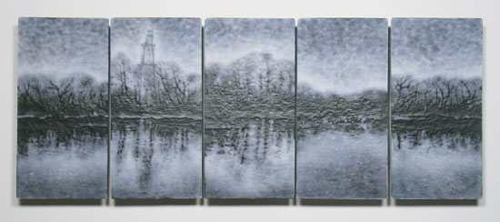
April Surgent, I'll Think of You From There, 2007
fused and cameo-engraved glass, 19.75 x 50.5 x 2.25 inches installed
Photo: R. Watson

