

300 NW 13th Avenue
Portland, OR 97209 USA
503-227-0222 phone
503-227-0008 fax
gallery@bullseyeglass.com
www.bullseyegallery.com

September 19, 2007 FOR IMMEDIATE RELEASE

Sylvie Vandenhoucke: Break of Day
Janice Vitkovsky: Beneath the Surface
International artists create detailed, patterned forms using disparate glass kilnforming techniques.

When: September 25 - November 17, 2007
Tuesday – Saturday, 10:00 am – 5:00 pm
(and by appointment)

Where: Bullseye Gallery
300 NW 13th Avenue
Portland, OR 97209 USA
View map

Artist Reception: Wednesday, October 3, 5:30 - 7:30 pm

First Thursday: October 4, open until 8:00 pm
November 1, open until 8:00 pm

Portland, OR - Bullseye Gallery is pleased to announce two solo exhibitions by international artists: Sylvie Vandenhoucke’s “Break of Day” and Janice Vitkovsky’s “Beneath the Surface,” both on view September 25 - November 17, 2007. Although achieved through different methods, both artists’ work has a keen sensitivity to detail and rhythm, witnessed in elaborate textures and patterns that remain restrained in color. The results are dissimilar but equable, a harmonious balance between the chaotic and sparse.

Sylvie Vandenhoucke is a Belgian artist and currently a Senior Lecturer at the University of Sunderland in the UK. Vandenhoucke uses the pâte de verre (“paste of glass”) technique, building a relief mold and then packing it with ground glass. The resulting wall-mounted pieces have a frosty, delicate texture, studded with a pattern of flower-like shapes. “The work reveals a non-physical or inner space, trapped between the layers of the miniature landscape,” says Vandenhoucke, whose sculptures have recently been shown in Japan, the UK, Belgium, and the US.

Janice Vitkovsky, a native Australian, graduated in 2005 from the Australian National University in Canberra. She honed her practice of the Italian murrine technique through a mentorship with Giles Bettison in 2003, and her sculptural works bear testimony to his attention to detail and craftsmanship. Miniscule slices of brightly-colored glass float and bend in unison, suspended in matte transparent forms; a glimpse into an microscopic, underwater world. “By working with pattern and layering, I wish to expose rhythmic and intricate patterns that relate to the inner workings and mysteries existing beneath the surface of our reality,” explains
Vitkovsky. The artist will attend a reception celebrating her exhibition at Bullseye Gallery on October 3, 2007, from 5:30 – 7:30 pm.

To view the artwork online or download the artists’ statements and CVs, please visit www.bullseyegallery.com. To receive additional information, request high-resolution images, or schedule an interview, please contact Nicole Leaper: nicoleleaper@bullseyeglass.com; 503-227-0222.

About the gallery: Bullseye Gallery works with a select group of international artists with the aim of furthering exceptional design in glass through innovation in material and method. The gallery is part of Bullseye Glass Company, a maker of colored glass for art and architecture since 1974.
###
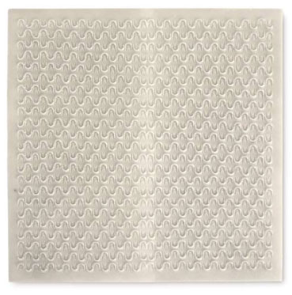
Sylvie Vandenhoucke, Stripe, 2007,
pâte de verre, 13.75 x 13.75 x .25 inches

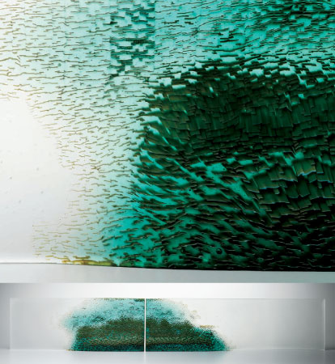

Janice Vitkovsky, Moment When Whole III, 2007,
fused and murrine glass,
6.875 x 41.375 x 1.5 inches installed
Photo: G. Hancock

