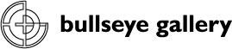

300 NW 13th Avenue
Portland, OR 97209 USA
503-227-0222 phone
503-227-0008 fax
gallery@bullseyeglass.com
www.bullseyegallery.com

November 30, 2010 FOR IMMEDIATE RELEASE

Mark Zirpel: Queries in Glass
Incompatibility, physical and emotional, is explored in a solo exhibition from Mark Zirpel.

When: Wednesday, January 5 – Saturday, March 26, 2011
Tuesday – Saturday, 10:00 am – 5:00 pm
(and by appointment)

Where: Bullseye Gallery
300 NW 13th Avenue
Portland, OR 97209 USA
View map

First Thursday: January 6, open until 8:00 pm
February 3, open until 8:00 pm
March 3, open until 8:00 pm

Portland, OR – Bullseye Gallery presents a solo exhibition by Mark Zirpel. Queries in Glass will be on view January 5 through March 26, 2010.

“My work often explores a convergence between art and science;” explains Zirpel, “both fields aspire to discovery.” Inquiry is the defining methodology of Zirpel's multi-disciplinary studio practice. "Questions give rise to answers that trigger questions." This circuitous process has resulted in multimedia exhibitions that often include programmable microcontrollers, glass casting, thermo sensors, kinetic sculpture, and blown glass. "I devise specific intent that guides my activity," he continues, "My work is multidisciplinary...context driven... and conceptually insistent." Queries in Glass encompasses the breadth of Zirpel's practice and follows the intersecting and divergent paths of his interests.

Mark Zirpel received a BFA in Drawing from the University of Alaska, Fairbanks and a MFA in Printmaking from San Francisco Art Institute. In 2006 he was awarded the Stephen Proctor Fellowship from Australian National University in Canberra. More recently he was a Tiffany Foundation Grant Nominee and has been a visiting artist at numerous institutions, including Ohio State University and Rochester Institute of Technology. Zirpel’s work can been found in the permanent collections of the Anchorage Museum of History and Art in Alaska, the Tacoma Art Museum in Washington, and the Progressive Collection in Cleveland, Ohio.

To view artwork online or download artist statements and CVs, please visit www.bullseyegallery.com. To request high-resolution images or to schedule an interview, please contact Michael Endo: michaelendo@bullseyeglass.com; 503-227-0222.
# #
About the gallery: Bullseye Gallery offers contemporary art objects and experiences examining the potential and complexity of kilnformed glass. The gallery is part of Bullseye Glass Company, a maker of glass for art and architecture since 1974.
# # #
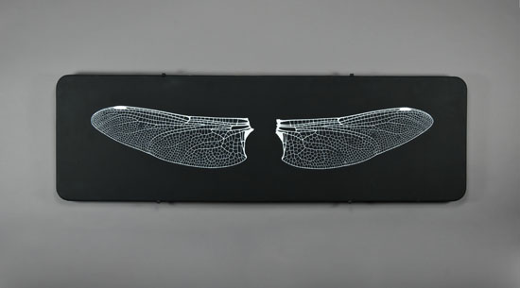

Mark Zirpel, Double Wing, 2006
kilnformed and sandblasted glass
19.125 x 62.125 x .25 inches
Photo: M. Endo, Image courtesy of Bullseye Gallery

