

300 NW 13th Avenue
Portland, OR 97209 USA
503-227-0222 phone
503-227-0008 fax
gallery@bullseyeglass.com
www.bullseyegallery.com

February 24, 2010 FOR IMMEDIATE RELEASE

e-merge 2010
Finalists from Bullseye Glass Company’s sixth biennial juried kiln-glass competition for emerging artists.

When: March 23 –June 19, 2010
Tuesday – Saturday, 10:00 am – 5:00 pm
(and by appointment)

Where: Bullseye Gallery
300 NW 13th Avenue
Portland, OR 97209 USA
View map

Award Ceremony: Saturday, March 27, 2010, 5:30 – 7:30 pm

First Thursday: April 1, 2010, open until 8:00 pm
May 6, 2010, open until 8:00 pm
June 3, 2010, open until 8:00 pm

Portland, OR – Bullseye Gallery is pleased to exhibit work by finalists from e-merge 2010, Bullseye Glass Company’s sixth biennial juried kiln-glass competition for emerging artists. 2010 marks the first year Bullseye Gallery will host the competition’s resulting exhibition, on view March 23 – June 19, 2010.

This year’s finalists, representing twelve countries, were selected from over three hundred entries. The exhibition recognizes students and early-career artists who are rising through the ranks of kilnformed studio glass, but who are not represented by major galleries. The finalists were judged on their excellence of concept, craftsmanship and design by a panel of three jurors. The three jurors for this year’s competition are Kate Elliott, Michael Rogers and Jeff Wallin.
e-merge 2010 exemplifies Bullseye Glass Company’s commitment to emerging artists. This international competition attracts hundreds of artists every two years, and has been the launch pad for many of kiln-glass’ newest talent. Carrie Iverson, an e-merge 2006 finalist, was a 2010 visiting artist and keynote speaker at Alberta College of Art + Design. Cobi Cockburn, also a finalist in 2006, received the 2009 Tom Malone Prize from Art Gallery of Western Australia. Jeff Wallin, a 2004 award winner, completed a residency at Vrij Glas studio in 2008 and is a juror for 2010’s competition.

Bullseye Glass Company is a small factory located in Portland, Oregon on the Northwest coast of the US. Bullseye hand casts colored glasses for artistic and architectural uses, runs an educational program, and hosts collaborative artist residencies known as “artist exchanges.” Founded in 1974 by three fresh-from-art-school graduates, the company has always harbored artists on its premises, even today when its 130+ employees must sometimes hurdle art projects in order to produce the 10,000 pounds of glass cast daily.
Bullseye Gallery works with a select group of international artists with the aim of furthering exceptional design in glass through innovation in material and method. The gallery is part of Bullseye Glass Company, a maker of colored glass for art and architecture since 1974.
To view the artwork online, please visit www.bullseyegallery.com. To receive additional information, request high-resolution images, or schedule an interview, please contact Michael Endo: michaelendo@bullseyeglass.com; 503-227-0222.
# #
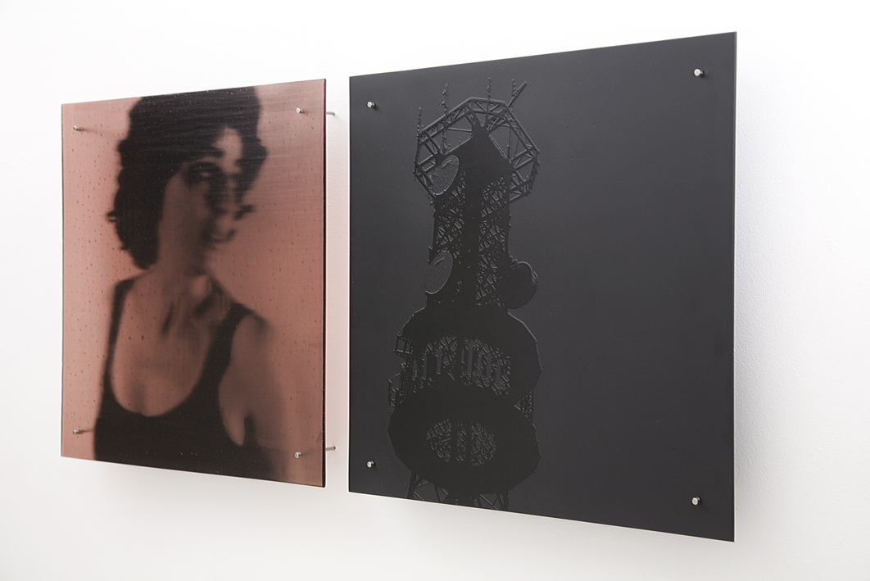
Kate Baker, untitled (Melina), 2009
kilnformed glass, 18.625 x 37.75 x 2 inches (installed)
Photo: Kate Baker

