

January 12, 2011

300 NW 13th Avenue
Portland, OR 97209 USA
503-227-0222 phone
503-227-0008 fax
gallery@bullseyeglass.com
www.bullseyegallery.com

FOR IMMEDIATE RELEASE

inFORM
Bullseye presents six recent graduates from art programs in Chicago, Canberra, and London.

When: Wednesday, February 2 – Saturday, April 9, 2011
Tuesday – Saturday, 10:00 am – 5:00 pm
(and by appointment)

Where: Bullseye Gallery
300 NW 13th Avenue
Portland, OR 97209 USA
View map

Artist Reception: Wednesday, February 2, 5:30 – 7:30 pm

First Thursday: February 3, open until 8:00 pm
March 3, open until 8:00 pm
April 7, open until 8:00 pm

Portland, OR – Gathering recent graduates from School of the Art Institute of Chicago, the Royal College of Art, and Australian National University, Bullseye is pleased to present an exhibition of work that explores interactivity, reflection, and play. inFORM will be on view February 2 - April 9, 2011.

Artists Avika Bhansali (SAIC), Heike Brachlow (RCA), and Stacy Lynn Smith (SAIC) ask the viewer to interact directly with installed works. Bhansali invites us to participate in the creation of her installation, drawing attention to the interplay of objects, architecture and ourselves. Brachlow plays with our fears and perceptions of glass's fragility with teetering sculptures that precariously rotate when touched. Smith's installation carries this concept to its logical conclusion; the work isn't complete until gallery visitors slowly destroy it. For Joseph Harrington (RCA), material interactivity is a vital component of the work's creation. His lost-ice sculptures are the result of an exothermic interaction, capturing forms in transition. The works of Ruth Oliphant (ANU) and Abi Spring (ANU) seek to illicit an internal interaction, creating a refuge from the constant demand of visual over-stimulation. Oliphant's uninhabited cityscapes are a dream-like reflection of the everyday, focusing on how we relate to the cities that we inhabit. Spring's subtle variation of tone and hue creates an optical vibration.

Kilnformed glass is not always the most obvious or accessible medium to express one's ideas. Glass courses and facilities are not as ubiquitous as painting studios. Despite this, the artists in this exhibition have sought out glass education both inside and outside of their institutions. While the reasons that these artists have chosen glass are many, their choice asserts one thing: glass is a plastic medium, capable of being manipulated and transformed. Transparent or opaque, subdued or vibrant, smooth or textured - glass is not bound by the properties that are traditionally associated with it.

To view artwork online or download artist statements and CVs, please visit www.bullseyegallery.com. To request high-resolution images or to schedule an interview, please contact Michael Endo: michaelendo@bullseyeglass.com; 503-227-0222.
# #
About the gallery: Bullseye Gallery offers contemporary art objects and experiences examining the potential and complexity of kilnformed glass. The gallery is part of Bullseye Glass Company, a maker of glass for art and architecture since 1974.
# # #
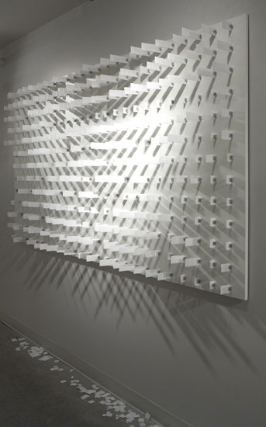

Stacy Lynn Smith, Selection, 2009
kilnformed glass, chrome, wood
48 x 96 x 4.5 inches (installed)
Photo: J. Sayer

