

300 NW 13th Avenue
Portland, OR 97209 USA
503-227-0222 phone
503-227-0008 fax
gallery@bullseyeglass.com
www.bullseyegallery.com

April 30, 2008 FOR IMMEDIATE RELEASE

Succession: The legacy of the Australian National University’s Glass Workshop, Canberra; curated by Klaus Moje

When: May 27 – August 2, 2008
Tuesday – Saturday, 10:00 am – 5:00 pm
(and by appointment)

Where: Bullseye Gallery
300 NW 13th Avenue
Portland, OR 97209 USA
View map

First Thursday: June 5, open until 8:00 pm
July 3, open until 8:00 pm

PORTLAND, OR – In 1983, Klaus Moje founded what would become Australia’s premier center for talent in glass art: the Glass Workshop at the Canberra School of Art, Australian National University. On the advent of Klaus Moje’s retrospective at the Portland Art Museum (May 31 – September 7, 2008), Bullseye Gallery Director Lani McGregor asked Moje to select a group of artists he felt best represented Canberra’s rich history. SUCCESSION, which will be on view from May 27 - August 2, 2008, features works by contemporary Australian artists and Canberra alumni Giles Bettison (1996), Claudia Borella (1995), Deb Jones (1989), Jessica Loughlin (1997), Kirstie Rea (1986), and Richard Whiteley (1987).
The Glass Workshop at the Canberra School of Art, Australian National University, is internationally recognized for the success of its graduates, their high standing among collectors of contemporary studio glass and, especially, the quality of their work within the burgeoning field of kilnforming. In the 25 years since its founding, the Glass Workshop has enjoyed a succession of exceptional masters, from founder Klaus Moje, through the late Stephen Procter and fellow course-leader Jane Bruce, to current program head Richard Whiteley. Over this same time period the program has also enjoyed a special working relationship with the Portland, Oregon factory, Bullseye Glass Company. The ongoing interchange of ideas and personnel has led to the development of new materials and new methods in an energetic symbiosis that continues to this day.
SUCCESSION traces these influences in a select body of work including Giles Bettison’s lace-inspired murrine work; Claudia Borella’s stylized solar and lunar cycles; Deb Jones’ reductive, cast shapes; Jessica Loughlin’s contemplative horizon lines; Kirstie Rea’s abstracted landscapes; and Richard Whiteley’s architectonic forms. As a group, these artists embody Canberra’s talent, innovation, and collaboration with its Portland partner, Bullseye Glass Company. SUCCESSION is a tribute to inspiring teachers, exceptional students, and the rich interface between artist and factory.

###

For more information on the Glass Workshop at the Canberra School of Art, Australian National University, please refer to www.anu.edu.au/ITA/CSA/glass.

To view artwork online or download artist statements and CVs, please visit www.bullseyegallery.com. To request additional information or high-resolution images, please contact Patrick Leonard: patrickleonard@bullseyeglass.com; 503-227-0222. To schedule an interview, please contact Jamie Truppi: jamietruppi@bullseyeglass.com; 503-227-0222.

About the gallery: Bullseye Gallery works with a select group of international artists with the aim of furthering exceptional design in glass through innovation in material and method. The gallery is part of Bullseye Glass Company, a maker of colored glass for art and architecture since 1974.

###

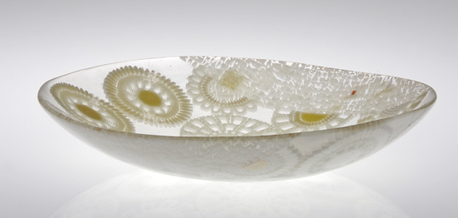
Giles Bettison, Lace 08 #2, 2008
fused, blown and coldworked murrine glass
2.5 x 11.25 x 10.875 inches
Photo: Andrew Dunbar

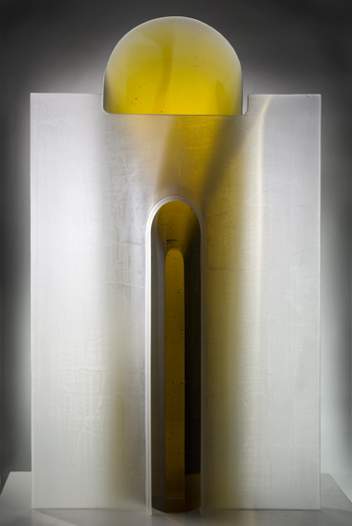

Richard Whiteley, Divide, 2008
kilnformed glass
40 x 23.5 x 8.5 inches
Photo: Rob Little

